**“UNDERSTANDING THE TRENDS IN FAST FASHION AND IT’S IMPACT ON APPAREL INDUSTRY”**

Live Project submitted in partial fulfillment of the requirements for the   
*award of the Degree of*

**`MASTER OF BUSINESS ADMINISTRATION   
of  
BANGALORE UNIVERSITY**



***Submitted by:***

***VISHAL ANAND KUMAR***

**Reg. No. P03EV21M0020**

**MBA (2021-23)**

Under the guidance of

***Dr. Naveen Pol***

**ASSOCIATE PROFESSOR**

**DEPARTMENT OF MBA**  


#107, INFOSYS Drive, behind BSNL Telephone exchange, Electronic City Phase 1, Bangalore 560100.1, Bangalore 560100.



**CERTIFICATE OF ORIGINALITY**

Date:

This is to certify that the Internship Project titled “Understanding the trends in fast fashion and it’s impact on apparel industry” is an original work of MS. SMITHA BH bearing University Register Number P03EV21M0006 and is being submitted in partial fulfillment for the award of the Master’s Degree in Business Administration of Bangalore University. The report has not been submitted earlier either to this University /Institution for the fulfillment of the requirement of a course of study or any other Degree.

SIGNATURE OF GUIDE SIGNATURE OF PRINCIPAL

Date : Date :

##### DECLARATION BY THE STUDENT

I hereby declare that “Understanding the trends in fast fashion and it’s impact on apparel industry” is the result of the project work carried out by me under the guidance of Mrs. Naveen pol in partial fulfilment award of my master’s degree in Business Administration from Bangalore University.

I also declare that this project is the outcome of my efforts and that it has not been submitted to any other university or Institute for the award of any other degree, Doma, or Certificate.

##### Place: Bangalore Name : SMITHA BH

**Date: Register Number: P03EV21M0006**

##### ACKNOWLEDGEMENT

I sincerely express my profound gratitude to Director Dr. Nila Chotai of ISBR College for extending greater support and assistance to complete the internship project.

I convey my sincere gratitude to our Project Guide Associate Prof. Dr. Naveen Pol of ISBR College as my instructor for her timely guidance and continued inspiration and encouragement for accomplishing the qualitative internship project.

Finally, I convey my sincere regards and thankfulness to all those, who supported my internship journey.

##### Place: Bangalore Name : SMITHA BH

**Date: Register Number: P03EV21M0006**

**GUIDE CERTIFICATE**

This is to certify that the project Report titled “***Understanding the trends in fast fashion and it’s impact on apparel industry***” Submitted by **SMITHA BH** and P03EV21M0006 to Bangalore University, Bangalore for the award of Degree of **MASTER OF BUSINESS ADMINISTRATION** is a record of work carried out by he/her under my guidance.

Place: Bangalore Dr. NaveenPol

Date: Signature

Table of contents

|  |  |  |
| --- | --- | --- |
| **CHAPTER NO.** | **PARTICULARS** | **PAGE NO.** |
| **01** | **Introduction** | **7 to 56** |
| **02** | **Company Profile** | **56 to 57** |
| **03** | **Research Design and Methodology** | **58 to 68** |
| **04** | **Data Analysis and Interpretations** | **68 to 84** |
| **05** | **Summary of Findings, Conclusions, and Recommendations** | **85 to 87** |
|  | **Bibliography** | **88 to 89** |

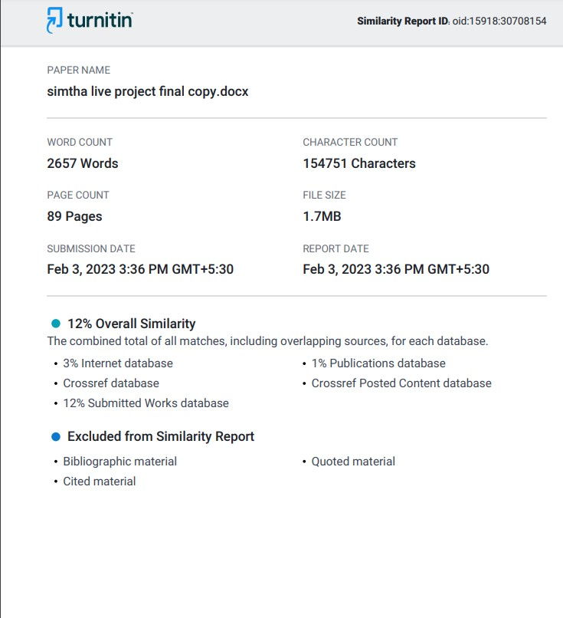

# CHAPTER – 1

# INTRODUCTION

All throughout our lives, humans still need the basic essentials of food, clothes, and shelter to survive. It goes without saying that it is quite significant. So the dilemma of how to obtain food, clothing, and shelter throughout life while also ensuring that the supply stays unaffected for both us and our future generations, without any obstacles or quality gradation, emerges. Every teenager has the aspiration of either partaking in or at the very least emulating the glamorous world, which has an influence on our environment and ecosystems through its lifecycle stages and apparel.

Fast fashion has grown to be a significant factor in the global problem of clothing waste as all fashion businesses strive to present the newest collections in order to boost profit margins, their brand reputation, and buzz. The fashion business has been dramatically transformed by this relatively new occurrence. Our environment and the fashion industry, which is closely related to the textile sector, are intertwined.

The quick manufacture and turnover of inexpensive, stylish apparel is known as "fast fashion." In order to stay up with the most recent fashion trends, many big stores now often release new collections. This business model has grown in popularity in recent years. However, because it frequently uses inexpensive, unsustainable materials and unethical labour methods, fast fashion also has a substantial negative impact on the environment and society.

The goal of this study is to examine the fast fashion business and its consequences on the environment and textile workers. We want to increase consumer awareness of the detrimental effects of fast fashion and encourage them to make more thoughtful decisions when it comes to their clothes purchases through research, analysis, and potential remedies.

However, more individuals seem to be recognizing the negative aspects of fast fashion, and some have even started to boycott it

# What is Fast Fashion:

It's possible that not everyone is familiar with the term "quick fashion." After all, because they are reasonably priced and open to a wide spectrum of individuals, many of us have never had to second-guess choosing to purchase at the most well- known apparel retailers. We have instant access to the hottest things. Without a question, feeling good about ourselves after purchasing new, inexpensive attire gives us more self-assurance the following time we go out.

But let's explore further. Fast fashion is the term used to describe the mass manufacture of inexpensive, fashionable, and frequently low-quality apparel. Primark, Shien, H&M, and Boohoo are well-known brands in the quick fashion sector, but there are many more as well.

The phrase "fast fashion" may not be well known to everyone. After all, many of us have never had to second-guess our decision to shop at the most well-known garment companies since they are affordable and accessible to a wide range of people. The newest products are available to us right now. Without a doubt, feeling good about ourselves after investing in new, affordable clothing boosts our confidence the next time we go out.

But let's look more closely. The phrase "fast fashion" is used to characterise the mass production of cheap, stylish, and usually low-quality clothing. There are several other well-known firms in the fast fashion industry in addition to Primark, Shien, H&M, and Boohoo.

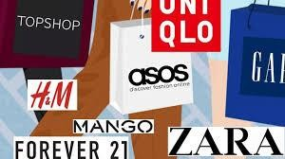

# The history and timeline of fast fashion:

Fashion was sluggish prior to the Industrial Revolution and the development of the sewing machine. People produced their own clothing and took the time to fix them as needed. Clothing was frequently made specifically for each person and was designed to last a lifetime. Imagine if that were typical! Eventually, individuals started dressing more for fashion and less for functional qualities like durability.

The term "fast fashion" was first used by the New York Times in the 1990s to describe the mass production of low-quality clothing, with Zara's new accelerated production model serving as their model. In this model, clothing was produced quickly from the design stage, with inspiration from Fashion Week to the stores for anyone to purchase.

**Here’s a timeline of the history of fast fashion that goes into a bit more detail:**

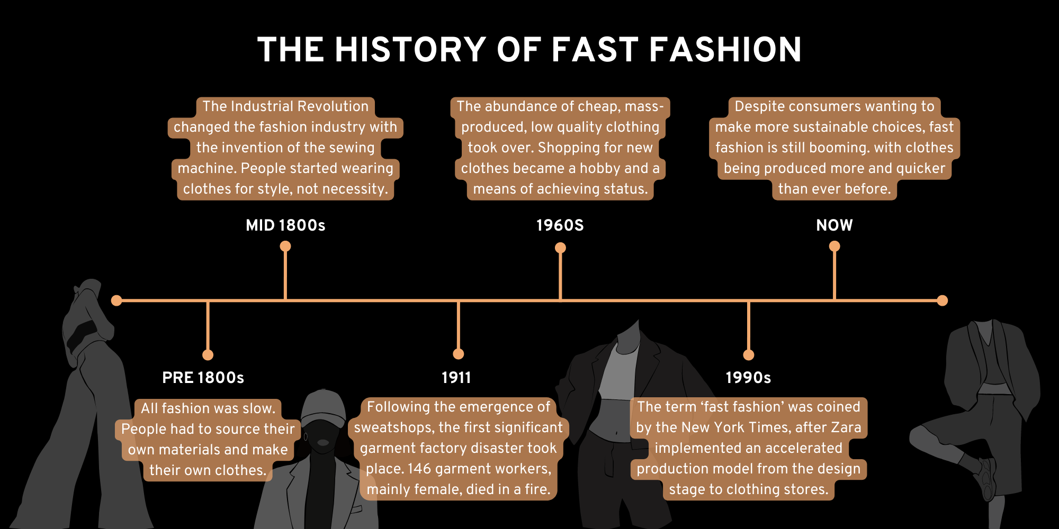

# Emergence of Fast Fashion:

The garment business has long relied heavily on labour and had modest capital requirements. In addition, the market has been defined by standardised production for a mass market and minimal entry barriers (Taplin 2014; 248). Climate-wise, it shouldn't have surprised anyone that garment businesses moved more and more of their production to developing nations, where there are plenty of low-paid, low- skilled people available. Globalization has become more prevalent over the past 20 years, which has led to the outsourcing of industry to underdeveloped nations. Cheap labour, large tax benefits, and lax rules and regulations are the draws of developing nations for garment firms.

According to current estimates, one in six individuals work in some capacity within the global fashion business, making it the sector most dependent on labour. Fast fashion was made possible by the garment industry's decision to relocate manufacturing to countries with lower labour costs. Fast fashion is a segment of the clothing market that was created in Europe to cater to the frequently shifting preferences of predominantly young women who want to keep up with current trends at a lower price.

Before fast fashion, shops had to put orders that would cover the demand for a full season, which required them to keep big inventory in storage. Due to the lack of time, it was difficult to predict customer demand, which frequently resulted in markdowns and reductions at the conclusion of the season. These problems paved the way for a new supply chain model, which is covered in more detail in the following chapter. The fashion pyramid, which is seen in Figure 1.3 below, was broken by the quick fashion segment of the garment business.

# How does Fast Fashion Works:

Today, an astounding 100 billion pieces of apparel are made each year. We think the amount is so enormous that it's difficult to even imagine it. The emphasis of fast fashion is on cost, accessibility, and convenience. The latter implies cost savings whenever feasible. One example of how this is done is by outsourcing the manufacturing of clothing to nations where there is a high demand for labour and where the cost of labour is also low. Vietnamese, Bangladeshi, Chinese, and Indian workers are among of the top choices for quick fashion.

Celebrities and catwalks provide brands with trend ideas, which they quickly translate into clothing to satisfy consumer demand. Their primary goal is to quickly produce large quantities of garments in order to capitalise on fads before they pass out of style.

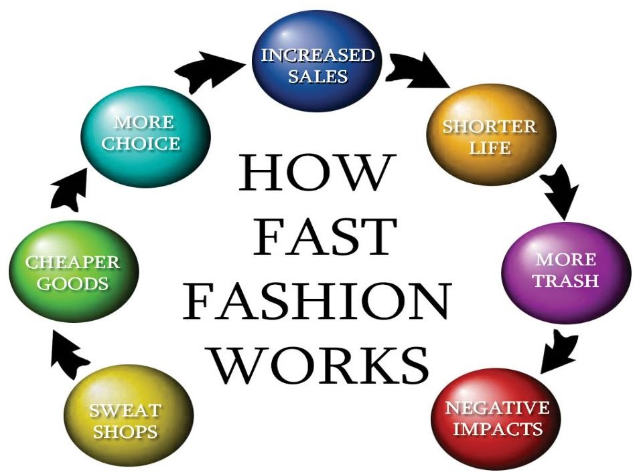

**CHAPTER - 2**

# INDUSTRY PROFILE

# 

# Apparel Industry:

The manufacture, production, marketing, and retailing of garments, including clothing, footwear, and accessories, is referred to as the apparel industry, often known as the fashion industry. It includes a wide spectrum of companies, from little freelance designers to significant global conglomerates. Manufacturing and production for the garment business take place in several nations all over the world.

The global economy benefits greatly from the billions of dollars in income the garment sector produces each. Millions of people are employed by it globally, including textile workers, manufacturing workers, designers, marketers, and shop staff. New trends and fashions are always appearing in the sector, which is continually changing. Changes in consumer behaviour, technological advancements, and general economic situations all have an impact on the sector. Demands from consumers for ethical and environmental products have risen in recent years.

Despite the garment industry's substantial economic contributions, it has come under fire for its detrimental effects on the environment and labour rights. This criticism has been fueled in part by fast fashion, mass manufacturing, and excessive consumption, but there are also several projects and groups inside the industry promoting ethical and sustainable production.

Women's, men's, and children's clothes are only a few of the subsectors of the apparel market, along with more niche categories including outerwear, activewear, and luxury fashion. The sector also includes textile manufacturing, which creates the textiles and components required to construct clothes.

# Overview of the apparel industry:

The rapidly evolving culture, politics, and economy of contemporary life have a significant impact on the industrial environment, particularly consumer sectors like the garment industry, which need enterprises to consistently enhance the quality and variety of their products. The garment business is in its boom stage as a result of the rapid rise in disposable incomes, the establishment of contemporary urban lifestyles, and the emergence of trend-conscious customers. The expansion of fashion trends together with the changing retail environment across brands are expected to propel the apparel market. Consumers' goals and expectations are changing quickly as they grow more savvy, sophisticated, and tuned in to their personal tastes.

The nation with the biggest young population naturally becomes one of the major apparel market buyers. Additionally, a rise in the proportion of women in the workforce demonstrates higher income equality and a rise in the number of households with two incomes, both of which enhance aggregate demand and spur market expansion. the ascending One of the reasons for the growth in the clothing sector is the penetration of social media. Through their social media platforms, channels link users to influencers and fashion role models who inform them about the newest trends and other facets of fashion.

# Global Apparel Market: Segmentation Analysis:

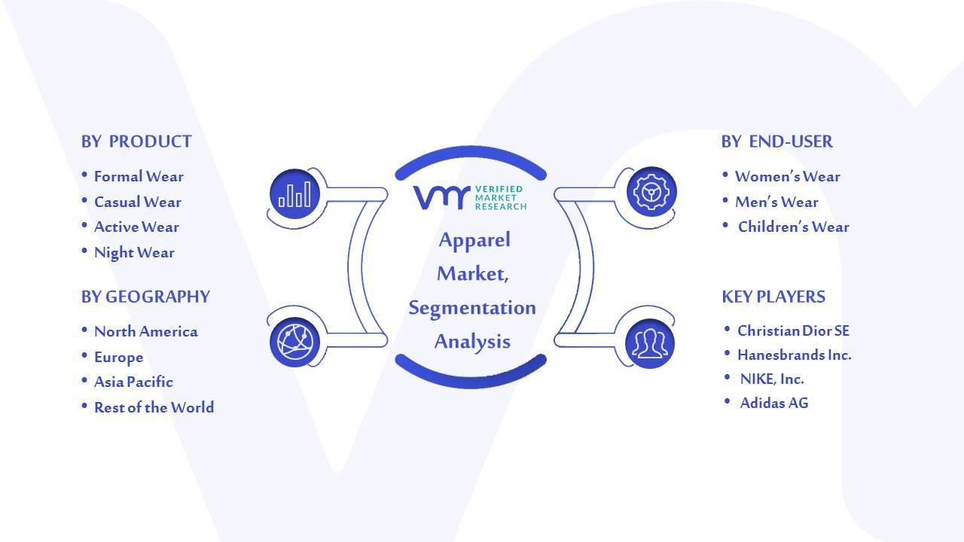The global apparel market is divided into segments based on product, end-user, fibre type, distribution method, and geography.

The following types of fibres are used in clothing: man-made, cotton, animal- based, and vegetable-based fibers.

The market is divided into four categories based on the type of fiber: man-made, cotton, animal-based, and vegetable-based.

# Apparel Market, By Distribution Channel:

* Online
* Offline

The market is divided into two segments: online and offline, based on the distribution channel. Offline distribution methods provide customers a close-up view of the items, enabling them to assess their quality and robustness. After saying that, In urban areas, where a relatively larger working population yearns for faster services because the industry is offering much more through online channels, demand for apparel has been experiencing extremely significant growth due to the rising penetration of smartphones and changing customers' preferences towards digital payments. The buying habits of customers have significantly changed as a result of Covid 19. Online shopping has surpassed in popularity in- person purchasing among consumers. As a result, the internet distribution channel is anticipated to develop the fastest.

# 

# Key players in the apparel industry:

1. **Manufacturer Exporters**: This group is responsible for purchasing fabric and accessories, sewing, finishing, cleaning, and packing the final products before shipping them to the traders. They should have their own production facilities in addition to their own import export code (IEC) number. Some suppliers operate as a conglomerate. Who produces their own clothing or accessories? When the quantity is large or the shipping date is approaching, they occasionally place the order to sub-contact the manufacturer.
2. **Merchant Exporters:** This organisation collects the buyer's purchase and sends it to a different producer so they may fulfil it by gathering fabric and other accessories. Despite dealing directly with the buyers, they lack sufficient production facilities. They eventually re-invoice and re-pack the items before shipping them to the merchants in their name. They also charge commission. Currently, the majority of them choose to establish clothing factories because they don't demand significant investment but are more difficult to manage.
3. **Buying house:** The buying house centre serves as a place where overseas buyers may conduct business with ease in local factories in other nations. This type of office was primarily established to monitor the operations of local business partners. The following procedures must be completed before buying a home.
4. **Liaison office:** This organisation serves as a conduit between a certain department, brand, or buyer and the vendor. They use their own merchandisers and quality control specialists. They examine the prices charged by the suppliers as well as the wearers' quality, fit, and washing results. This type of office was primarily established to monitor the operations of local business partners. Only large purchasers are able to establish a standalone liaison office since their volume of business requires it. They also assess the vendor's ethical standards, which is a compliance concern. An illustration would be Walmart in Gulshan, Dhaka.
5. **Textile:** It is that organisation that creates fabric, the primary component of the wearer. Textiles come in solid and yarn-dyed varieties. 60% of the cost of the wearer is made up of fabric. CVC twill, end-on-end, seer sucker, gingham, linen, TC pocketing, corduroy, spandex twill, canvas, and denim are all common fabrics. The cutting-edge textile product benefits the garment industry. Even the manufacturing schedule for the garment industry is based on the lead time and quality of textile goods.
6. **Buying Agent:** Inevitably, buying agents are important to the garment sector since they provide as a link between buyers and exporters. This company is capable of conducting business with several clients and directing orders to various suppliers. Their clients include many brands. It is a truth that small and medium- sized purchasers lack the power to establish a private purchasing house in their favour owing to the low number of activities. As a result, they would rather the buying agent carry out their business elsewhere. An example is the Comte tile at the Agra Bad in Chittagong.
7. **Workers:** The garment sector employs two different categories of people. There are two categories of workers: white collar and blue collar. They are both unavoidable for the sector. To complete the order, they must have the requisite machine, sewing, fabric, measuring, washing, and packing skills. They adhere to TQM and place a strong emphasis on supply chain management.
8. **Suppliers:** This organisation is in charge of giving producers access to raw materials and accessories. To speed up production, they may offer fabric, yarn, zippers, or other accessories, as well as any essential equipment or spare parts, and service-oriented tasks like paperwork, logistics, shipping, banking, etc. These vendors contribute significantly to the garment industry by offering goods or services. After reading the aforementioned essay, we can see how these actors' contributions have led to the RMG sector's fast domestic and international expansion.

##### Supply Chain Management in Apparel Industry:

When it comes to controlling the flow of products and services required to run a business, there are many moving components. In today's cutthroat marketplace, how well—or how poorly—you manage those moving elements may make or destroy your brand.

While efficient supply chain management is essential for every company, those of us in the garment sector need to remember this more than others. The supply chains for clothing and fashion shops are sometimes more complicated than those of other sectors due to rapidly evolving fashion trends and an infinite range of items. Because of this, it's critical to comprehend all of its components in order to effectively manage it.

##### How can consumer behaviour change the fashion industry?

The earth's resources are being severely impacted by the fashion industry, which is the second most polluting sector of the global economy. Due to the demands of fast fashion and the textile industry, there are negative effects on natural resources, labour exploitation, and environmental harm from the manufacture, waste, and disposal of clothing. The manufacturing of eco-friendly textiles is one way that many producers, brands, and suppliers are currently tackling sustainability challenges, yet this is insufficient. Consumers must take the lead if they are to truly impact the sustainability of textile production. Consumers have the authority to make change demands. However, altering consumer attitudes regarding fast fashion is a complicated process, therefore industry must work together to make changes that are actually beneficial.

Consumer Behaviour Characteristics in fashion industry :

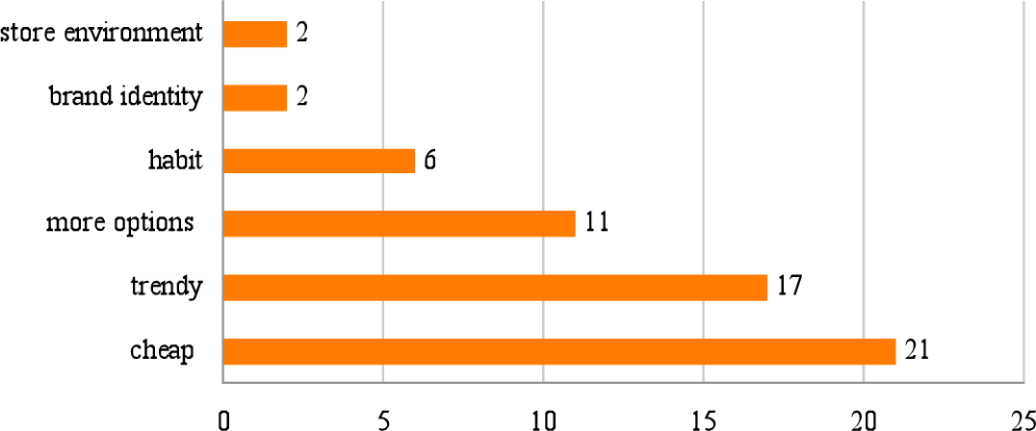

**Consumers must take more responsibility for creating sustainable:**

The need for more environmentally friendly and sustainable fashion solutions has been met by the fashion industry. In the business, movements like Fashion Revolution, Fair Wear, and Clean Clothes are beginning to acquire support.

Suppliers and brands are creating and utilising more environmentally friendly manufacturing processes, developing eco-friendly fabrics and dyes, enacting CSR policies, proactively educating their customers about the sustainability of fashion, and streamlining textile supply chains to cut down on waste. Although these actions are having an effect, consumers are still hesitant to buy sustainable clothing. The fashion business won't be able to transform or have the will to do so without their support. Additionally, consumers must exercise some accountability.

##### Consumers have complex buying behaviours:

Consumers have a challenging procedure while purchasing clothing. Cost, individual circumstances, vast overconsumption, lack of understanding of the fashion business, and the emotional components of self-image, impulse purchases, and always changing fashion combine to produce a challenging combination of behaviours to try to modify.

##### Encouraging the consumer to change their fashion buying behaviour:

* Due to the complexity of fashion consumption, encouraging consumers to purchase or demand sustainable clothing and textiles is not a simple problem to solve. In order to create momentum and long-lasting change, a joint strategy between consumers and producers must be devised. Numerous established manufacturers and start-up firms are creating programmes to entice customers to purchase sustainable clothing.
* Raising public awareness of the negative effects of rapid fashion on the environment and the advantages of sustainable fashion. Campaigns like the Sweatshop series and those from top retailers like M&S' Plan A will have a significant influence on informing customers.
* In order for customers to desire to buy and wear sustainable clothing, brands must make it fashionable. Fashionable apparel should be prioritised in sustainably produced clothing if we wish to change consumer purchasing habits.
* Industry and manufacturers must create effective programmes for recycling and trash reduction that are simple for consumers to use and take into account pre- and post-recycling streams. It is crucial to ensure that clothing and textiles can be recycled efficiently and readily from the start.
* Creating novel and distinctive methods for customers to interact with fashion. Leading the way in this field are several eco-focused start-up businesses that encourage customers to consider their fashion purchases while providing guilt-free options. These include Rendezvous, Tom Crosland's 30-year jacket, and MUD Jeans, which unveiled their guilt-free "Lease A Jeans."
* Investing in marketing initiatives to encourage people to appreciate existing clothing rather than continuously purchase new ones. With the help of campaigns like "Love Your Clothes," consumers may make simple, intentional modifications to increase the sustainability of apparel throughout its lifespan.
* The idea of materialism has to be investigated. Although it is a challenging process, ultimately both producers and consumers must accept accountability for their own excessive consumption.

##### Environmental Impacts of Fast Fashion:

The world of fashion has seen a seductive assortment of newness. When there are so many possibilities at the mall, it is really challenging to hang onto our old items and continue wearing them. In addition, more individuals than ever are buying stylish products because to the rise of internet shopping. Have you ever paused while busily filling your basket to consider how many resources are used to produce all those clothes?

We must monitor the carbon footprints that the fashion industry is leaving as customers. We are aware that the holiday shopping season is upon us, and you have been anticipating it with bated breath, but let's talk about the environmental implications first.

##### Carbon emissions:

The release of carbon dioxide (CO2) into the atmosphere is referred to as a CO2 emission, sometimes known as a carbon emission. Burning biomass and fossil fuels, managing land usage, and industrial output are all factors that contribute to CO2 emissions. As the main greenhouse gas (GHG), CO2 has a considerable impact on the Earth's radiative balance and contributes greatly to climate change and global warming. The largest contributor to CO2 emissions is the apparel sector. These are specifically related to the creation of synthetic materials as well as the enormous amounts of prematurely abandoned things that are burned or dumped in landfills.

##### Dyes:

Natural and artificial dyes chemically bond with the materials they are applied to. Because textile production frequently takes place in regions that already experience water shortages, the use of textile colours places substantial demands on water usage. Due to a lack of proper environmental and health and safety laws in many textile-producing locations, the dyeing process is also a significant contributor to water contamination. Unfiltered wastewater is thus frequently released into nearby waters. This poses major risks to the environment and human health, which are made worse by the fact that many colours include heavy metals like lead or cadmium and some of them can degrade into chemicals that cause cancer. The ongoing distribution of these chemicals through domestic laundering raises further issues.

##### Chemicals:

Chemicals are intentionally created materials that are created or utilised in processes that alter atoms or molecules. Although the effects of different chemicals vary, the manufacture of fashion items mainly rely on the usage of substances that have a negative influence on the environment, including reduced soil fertility and water pollution, as well as pose major health risks. For weed control and yield enhancement, chemical pesticides and fertilisers are utilised in the production of natural materials like cotton. In order to turn fibres into yarns and yarns into fabric, chemicals are also required. Chemical-intensive stages of textile production include dyeing, surface treatments, performance-improving coatings and treatments, application of water and stain repellents, and the use of flame retardants. Those who handle these compounds face serious health hazards, frequently in settings with insufficient health and safety precautions. The usage of dangerous substances is still a common practise among world-renowned businesses, despite slow improvements. Additionally, materials used at various stages of manufacture frequently persist in textiles, and their slow release throughout usage presents additional risks to the health of people and the environment.

##### Cotton:

One of the first textile fibres to be developed, cotton is a soft fibre that develops in bolls, or protective casings, on cotton plants. Around 75 largely developing nations utilise 2.3% of the world's arable land for cotton growing, with China and India leading the way globally. Cotton is a significant cash crop that generates revenue for millions of farmers, but it also has negative social and environmental effects. 1 kilogramme of cotton, which is equal to 4 T-shirts, requires an average of 10.000 gallons of water worldwide. Although cotton can withstand heat and drought to some extent, a consistent water supply boosts yields and enhances quality and fibre length. As a result, it's thought that irrigation is used to grow roughly 3/4 of cotton. This has negative effects on local water balances and water supplies in places like Egypt, Uzbekistan, Pakistan, and Australia where there is already a water shortage. Cotton is also very susceptible to insect infestation, and traditional cotton agriculture (as opposed to GM crops, organic cotton, or Better Cotton Initiative (BCI) cotton) uses the most pesticides per unit of production of any crop. Water contamination from toxic pesticides used in cotton farming also has long-term effects on soil fertility, insect resistance, and biodiversity loss.

Additionally, they provide major health risks to nearby populations, particularly for those who handle them, such as child labourers. However, cotton's technical qualities and physical comfort are difficult to equal, and there aren't any similar substitutes on the market right now. The best selections are made up of organic cotton, BCI cotton, and other cotton that has been farmed in a more ethical manner. These choices, however, still only partially address the cotton market.

##### Distribution:

In the context of manufacturing, distribution refers to the transportation and logistics of raw materials, components, and unfinished goods, as well as the delivery of finished goods to customers through retail stores or online sales. The global nature of the fashion supply chain means that while raw materials may originate in one nation, it is more likely that they will be spun into yarn in another, then shipped to be woven into fabric somewhere else, where they will then be finished in a different location from where the final product will be produced.

Since the 1990s, there has been a rapid shift to offshore manufacturing, which means that the majority of these processes typically take place far from the commissioning company's and its target market's geographic locations. As a result, finished goods are shipped once more to the location where they are sold. The collective travel and distribution add to the total ecological footprint of fashion goods and have an influence on all of the above. Despite this, compared to other points along the fashion value chain, the influence of distribution is thought to be somewhat minimal.

##### Dust:

Dust is a small, solid, dry particle that can be carried by the air. The term "dust pollution" describes the air pollution caused by diverse types and sizes of dust particles. Domestic dust, pollen dust, sand dust, road dust, metal dust, silica dust, paper dust, plastic dust, or textile dust are a few examples. Due to the fact that the particles that inflict the greatest harm are sometimes invisible, exposure to dust pollution is associated with health risks that can go unrecognised for a long time. The handling of dyestuff in textile finishing as well as other cotton and wool procedures are linked to significant health concerns in the fashion and textile industries. These include cancer, occupational asthma, chronic bronchitis, and byssinosis, a respiratory disorder that impairs breathing and produces chest tightness. Dust pollution is a problem that affects employees everywhere, but in major industrial nations like China, India, Pakistan, Myanmar, or Bangladesh that still don't have strict health and safety regulations, its negative effects are exacerbated by a lack of preventative and protective measures.

**ECONIMIC GROWTH:**

**Efficiency:**

Efficiency is the ratio of resources and effort used to accomplish the desired goal. Due to advancements in research and technology, significant reductions in energy usage and CO2 emissions have been made in the fashion industry. However, the rate and amount of production, consumption, and waste are always increasing, negating the overall advantages of these reductions. For instance, despite reporting a 30% gain in resource efficiency per unit between 1980 and 2010, the fashion industry is nevertheless thought to have sold almost twice as many new clothing by 2007. This means that if industrial expansion continues at a rate that raises market demand and customer expectations, technical solutions to resource efficiency will be of little consequence.

##### Energy use:

The quantity of energy needed to manufacture things and render services is referred to as energy utilisation. Energy utilisation is highly demanding throughout the whole life cycle of fashion items. This process begins with the development, manufacture, distribution, and sale of the fibres and continues with domestic laundry and use-related maintenance. Recycling, incineration, and disposal in landfills all need a significant energy input at the disposal step. All of these activities primarily rely on non-renewable resources like fossil fuels, which not only deplete natural resources but also worsen the environment due to significant emissions of CO2 and greenhouse gases (GHG). While significant reductions in energy use and emissions per unit have been made because to technical advancement and research, these advantages are essentially lost as a result of the rapidly increasing rates of fashion production, consumption, and trash creation.

##### Environmental costs:

Costs associated with the actual or prospective deterioration of natural resources as a result of economic activity are defined by the United Nations as "environmental costs." The idea of the Triple Bottom Line, which broadens traditional accounting's focus beyond just accounting for financial transactions and profit (the bottom line) to include taking into account the effects that company operations have on people (the social bottom line) and the environment (environmental bottom line).

##### Externalized costs:

Negative externalities, also known as externalised costs, are social and environmental expenses that enterprises shift to other parties—typically those who have little control over these developments—in order to increase their profits. The issue of externalities is particularly related to the acute knowledge that the Global South bears a major portion of the social and environmental costs of commodities purchased in the Global North. These nations frequently provide inexpensive labour, but they still typically don't have stringent environmental regulations regarding manufacturing, the disposal of industrial waste, or an adequate level of protection for workers' rights, health, and safety. This was regrettably brought to light by the April 2013 collapse of the Rana Plaza building in Bangladesh, which resulted in 1,134 employees who made apparel for high-end international retailers dying and many more suffering crippling, life-altering injuries.

##### Genetically modified (GM) crops:

Genetically modified crops are agricultural plants that have had new genetic material inserted into them. This alters or enhances their natural properties, such as their susceptibility to pests, diseases, and the environment, as well as their nutritional value. Genetically modified cotton, sometimes referred to as biotech or Bt cotton, is one illustration. To strengthen the crop against widespread pests like bollworm, the gene of the naturally occurring soil bacterium Bacillus thuringiensis is added to the cotton plant. According to estimates, more than 75 percent of the cotton produced worldwide is now genetically engineered.

In compared to traditional cotton, it is reported to give better yields. It typically eliminates the requirement for fertiliser use as well. While using genetically modified cotton has advantages such as more effective growing and a decrease in the need for agricultural chemicals, genetically modified crops have also come under fire for corporate monopolies over the technology as well as for their potential environmental effects such as the development of pest resistance to resistant strains, potential persistence in the environment, and potential transfer of modified genes to other crops.

Additionally, some have claimed that the high input costs of Bt seeds and the accompanying debt are to blame for the rise in farmer suicides, however there is currently insufficient data to support this claim. Cotton growers are thought to have greater suicide rates than other types of farmers (NB: Valid at the time of writing, December 2019).

##### Growth:

The Club of Rome-commissioned paper The Boundaries to Growth said that the planet's environmental limits may be reached within the next 100 years if existing trends of exponential economic and population growth persisted. The Earth's environmental boundaries will be achieved sooner than the authors had anticipated, according to an updated version of the study called Beyond the Limits, which release timed with the 1992 United Nations Earth Summit.

It is becoming more and more obvious that attempting to achieve exponential economic development in the face of the planet's limited resources would have terrible global repercussions for both the environment and mankind. The idea of a post-growth economy has also become more popular as a result of this. Post- growth theorists emphasise that economic expansion must carefully examine the future prosperity and well-being of both people and the earth since it cannot be divorced from environmental constraints.

##### Hazardous chemicals:

Chemicals that are recognised to pose substantial risks to both human and environmental health are considered hazardous. These might include—but are not limited to—substances that are endocrine disruptors, carcinogens, mutagenics, hazardous for reproduction, allergens that trigger skin and respiratory responses, persistent, bioaccumulative, or toxic when introduced into aquatic systems and the environment.

Chemical usage is prevalent throughout the whole textile production process. Solvents, surfactants, water and soil repellents, biocides and pesticides, dyes/pigments, flame retardants, plasticizers, and pigments are among the most often employed hazardous chemicals in the pre-treatment, dyeing, printing, and finishing phases of the textile production process. For instance, a non-exhaustive list of 1900 chemicals used in the manufacture of textiles was prepared in a policy suggestion report by the Swedish Chemicals Agency, of which 165 were classified as dangerous under EU law.

##### Incineration:

Incineration is the burning-based technique of destroying garbage. While there are substantial geographical variations in collecting rates, it is estimated that only around 25% of old clothing is reused or recycled globally. While incineration is generally better than landfilling since it recovers some energy from the product and lowers the amount of garbage in landfills, it significantly increases the carbon footprint of fashion goods by emitting dangerously high quantities of CO2. Additionally, burning results in the accumulation of poisonous ash tainted with heavy metals (including lead and cadmium) and other extremely harmful compounds (e.g. dioxins).

The ash is frequently dumped in landfills, where it can leak and seriously harm both the environment and people. The practise of burning new, unsold inventory to preserve the value of fashion brands is still commonplace, which is particularly concerning given the impending climate disaster.

##### Irrigation:

Systems that distribute regulated water amounts to agricultural crops or land are referred to as irrigation. The irrigation of crops used to make textiles, particularly cotton, places heavy demands on water utilisation. Because cotton is frequently grown in areas that already have water shortages, this is a major concern. Despite some drought and heat tolerance, cotton benefits from a consistent water supply since it produces more and has better quality and longer fibres. As a result, irrigation is thought to be used in 73% of cotton production worldwide. But irrigation techniques frequently waste and result in further water loss before reaching the crop. Aside from harming local water supplies like rivers and lakes, improper irrigation management and excessive water withdrawal also have a negative influence on the local food supply, biodiversity, and public health.

Additionally, irrigation is a labour-intensive job that is known to use child labour in areas with inadequate irrigation infrastructure.

##### Landfill:

A landfill is a plot of land where trash is buried beneath several feet of soil. Only around 25 percent of old clothing is thought to be recycled or repurposed globally, and while recycling collection rates vary greatly by area, on average, about 75 percent of wasted clothing is either burned or dumped in landfills. This is equivalent to one garbage truck of textiles being dumped every second, according to the Ellen MacArthur Foundation. Landfilling wastes priceless resources that were used to produce clothes since a large amount of the clothing that is disposed of is still useful and valuable. Large-scale economic and environmental impacts are also associated with landfill dumps. For instance, landfilled apparel costs the UK economy £82 million a year at an average cost of £100 per tonne. Importantly, methane and CO2 emissions from landfill dumps contribute to air pollution.

Additionally, because they need a lot of space, they have a negative impact on local landscapes, soil fertility, and biodiversity. With frequent occurrences of spontaneous combustion, landslides, and high levels of poisonous gas emissions in the vicinity, the urban garbage dilemma in developing nations like India poses major health risks to both landfill scavengers and residents. Another issue is the global threat that groundwater pollution from landfill leaks poses to human health and local ecosystems.

##### Microfiber pollution:

Microfibers, which are fibres with a diameter of less than 5 mm, are shed from textiles and apparel at every step of their life cycles, from manufacture through usage and disposal. Although synthetic materials like polyester, nylon, or acrylic are associated to the shedding of a particular subgroup of microfibers termed microplastics, microfibers are shed from both natural and manmade materials (plastic particles less than 5 mm in size). Up to 20–35% of all main source microplastics in the oceans are thought to come from synthetic textiles, and this trend is growing. The discharge of microfibers is now acknowledged as a significant contributor to ocean pollution, and marine life suffers as a result of ingesting tiny plastic particles. As microfibers penetrate food chains and have the capacity to transport dangerous substances that linger in the environment, there are rising worries about the possible health effects on people.

##### Natural materials:

Natural materials may be broadly divided into two groups: cellulose- or plant- based materials (including cotton, hemp, and linen) and protein- or animal-based materials (e.g., wool, silk, leather, down). Although natural materials are frequently promoted as the "better" and more advantageous substitute for synthetic ones, the social and environmental effects of all materials differ depending on their origin and production methods. For instance, cotton is a crop that has high water consumption needs to improve crop yields and fibre length, which is quite troublesome given that it is planted to a considerable extent in regions that already experience water shortages.

##### Noise pollution:

Any sound can be considered noise, especially one that is unwanted, unpleasant, or upsetting. Constant noise in a particular location, such as a house, office, or region, is referred to as noise pollution. Despite the fact that ambient noise pollution is a problem that frequently goes unreported, its effects worsen over time. Regular noise exposure has a negative effect on people's health and wellbeing. These include sleep disorders, heart conditions, irritability and other mental health conditions, impaired cognitive function, hearing loss, and hearing impairment. More people than ever before are now exposed to noise pollution as a result of industrialization, globalisation, and urbanisation. The fashion and textile sector has an enduring issue with noise pollution, particularly in spinning and weaving machines. One of the many occupational health risks facing the millions of textile workers throughout the world who are exposed to noise levels every day that routinely exceed permitted limits is noise-induced hearing loss (NIHL).

Through noisy activities, traffic noise related to distribution, and the increasing number of home deliveries and returns, the industry also significantly contributes to ambient noise pollution in industrial and urban areas.

##### Off-cut waste:

Fabric scraps that are left over after clothes have been cut out are referred to as off-cut waste. Off-cuts may be little cutting scraps that are frequently combined with leftover yarns or bigger pieces that are roughly half a metre in length. The size of production off-cuts varies on design, manufacturing processes, and how pattern components are arranged on fabric (lay plan). Off-cut waste makes up a sizeable amount of the textile waste produced in industrial garment manufacture, although volume estimates vary because data on production waste is rarely routinely kept in factories. If other manufacturing waste is added, such as end-of- roll textiles, excess stock, overproduced goods, or fabric and garment rejections, the quantities increase even more. In major producing nations like China, India, or Bangladesh, where a lot of residual textiles are produced without the proper waste pathways, manufacturing textile waste is particularly problematic. This indicates that while some production waste is recycled, the majority of discarded textiles are still burned or disposed of in landfills. A growing number of companies and technology start-ups are investigating how digitalization and zero-waste methods might be used to optimise manufacturing waste. Innovative micro and small fashion companies are adopting innovative ways to utilise production waste in the creation of new fashion items. However, there are still several interwoven economic, legal, and infrastructure impediments to such operations on a worldwide scale. Insufficient infrastructure for recycling the different types of textile waste that are currently recyclable is another issue, along with a lack of financial incentives for the re-sale of production waste, administrative obstacles to the transfer of textile leftovers from producers to recipients, unclear regulations regarding end-of-waste criteria (when textiles are waste and when they are a material), and unclear regulations regarding end-of-waste criteria.

##### Overconsumption:

Overconsumption is a form of excessive consumption that exceeds both the ability of the world's ecosystems to regenerate and the actual requirements of humans.

Since the 1950s, fashion consumption rates have increased in the Global North, followed by comparable trends in developing nations like India and China. But since the fast fashion model was developed in the 1990s, the consumption of fashion has increased significantly.

Research reveals that clothing is frequently worn for less than a season, and high turnover of fashion goods is now a common practise in many parts of the world. The average number of times a garment is worn before being discarded has reportedly reduced by 36% percent globally over the past two decades, and China now has lower average wear rates than Europe. Large amounts of expensive clothing are frequently abandoned, and because only a tiny portion may be recycled, the most are either destined for incineration or landfills. In addition to the worrisome amounts of trash, the "endless cycles of yearning and disappointment" associated with quick changes in design might have a severe impact on the wellbeing of consumers of fashion.

##### Packaging:

Packaging is the covering used to safeguard items during various phases of production, distribution, sale, and usage. The rising worries about the waste streams produced by the fashion industry are particularly highlighted by the usage of plastic packaging and accessories across the whole value chain. Single-use plastic is widely used in a variety of applications, including covers for fabric rolls and component deliveries to manufacturers, individual protective wrappers for clothing as it enters a store or warehouse, garment hangers in homes and retail establishments, shopping bags, and wrapping for the delivery of online purchases. According to estimates, consumer products' packaging currently makes up the majority of the 150 million tonnes of plastic waste in the ocean, or 26% of the total volume of all plastic used.

##### Polyester:

The most popular synthetic fibre in the world, together with cotton, makes up the bulk of the global fibre market. Its production is correlated with significant CO2 and other greenhouse gas (GHG) emissions and heavily depends on non- renewable resources like petroleum and carbon-based fossil fuels. Polyester needs a lot more energy to produce than cotton since the production process is so energy-intensive. However, it often uses a small percentage of the water that cotton does. Polyester is becoming more and more linked, along with other synthetic fibres, to microfiber contamination, notably microplastics that imperil marine life and provide major hazards to human and environmental health.

Recycled polyester and bio-based polyester are now available as alternatives, however they still only account for a small portion of the polyester industry. Additionally, polyester substitutes continue to contribute to microfiber pollution in a similar manner to traditional polyester.

##### Post-consumer waste:

Trash produced after a product has reached its intended customer is referred to as post-consumer waste. Examples include both priceless new products that were bought and then thrown away without ever being used, as well as old and worn- out apparel and accessories.

##### Pre-consumer waste:

Pre-consumer waste is trash produced prior to a product's intended customer. Examples include leftover leather and fabric from the production process, surplus fabric supply, and unsold completed goods.

##### Synthetic materials:

Natural polymers, such viscose, lyocell, and acetate, or synthetic polymers are used to create synthetic materials (e.g. polyester, nylon, acrylic). In order to manufacture goods, a lot of chemicals, a lot of energy, and non-renewable resources must be used. High levels of CO2 and greenhouse gas (GHG) emissions are also produced by burning fossil fuels to power chemical factories. However, each synthetic substance has different effects depending on where and how it is made, much like with natural materials. For instance, unless the wood is produced and harvested under an ethical forestry initiative like Canopy, the manufacture of rayon (viscose, modal, and lyocell) leads to worrisome rates of deforestation. A growing number of studies link synthetic materials to microfiber contamination and the release of microplastics, which threaten human health and marine life.

##### Take-make-use-dispose model:

The term "linear take-make-use-dispose model" describes a method of production and consumption in which resources are harvested, used, and then disposed of without taking into account their state at the end of their useful lives or their ability for regeneration. By keeping materials, goods, and resources in use for as long as feasible through repeated cycles of resource recovery and regeneration, the circular economy model and closed-loop recycling solutions seek to minimise the depletion of natural resources and reduce waste and pollution.

**Water:**

Material that is thrown because it is unneeded, excess to needs, or undesired is referred to as waste. Offcuts from the production process, extra stock of fabrics and items that haven't sold, superfluous packaging, and unused goods that have already been purchased are just a few examples of waste related to the fashion business. The typical business strategy for the fashion industry is take, make, use, and discard. Making products with ever-shorter active lives depletes large amounts of resources, primarily non-renewable onesMaterial that is thrown because it is unneeded, excess to needs, or undesired is referred to as waste.

Offcuts from the production process, extra stock of fabrics and items that haven't sold, superfluous packaging, and unused goods that have already been purchased are just a few examples of waste related to the fashion business. The typical business strategy for the fashion industry is take, make, use, and discard. Making products with ever-shorter active lives depletes large amounts of resources, primarily non-renewable ones. In the context of fashion, waste may also refer to the undervaluing of design and production skills used in items that are either not worn or abandoned, as well as the financial waste caused by consumers purchasing items that are rapidly discarded.

##### Water pollution

Water pollution is the term used to describe how human activity has contaminated rivers, lakes, seas, groundwater, and drinking water supplies. Waterways are contaminated with harmful chemicals from all phases of textile manufacture, including operations like dyeing and finishing, as well as runoff from pesticides and fertilisers used in the production of natural materials. During the usage phase of garments, particularly through home laundry, chemicals and microplastics are released, contributing to further contamination. Large quantities of discarded and unsellable clothing dumped in landfills create leaks into rivers, which further exacerbate water damage. With more than 200 textile industries located along its riverside, the Citrus River in Indonesia is regarded as the most polluted river in the world.

##### [Social, Cultural and Economic Impacts of Fashion](https://www.condenast.com/glossary/social-cultural-and-economic-impacts-of-fashion):

Fashion is a potent social and cultural force that promotes communication and creative expression among individuals, groups of people, and entire nations.

Fashion product manufacturing relies on skilled labour that provides jobs, upholds important artisan traditions, and motivates generations of creative communities throughout the globe. However, the fashion industry also engages in activities that support child labour, modern slavery, poverty, and jeopardise animal welfare, and it has a famously complicated supply chain. As its methods may both celebrate and incite concern around body image and identities related to gender, race, and religious views, the fashion industry is also tied to people's general well-being.

Cash crops like cotton require a lot of labour to produce. According to estimates, 168 million youngsters worldwide who are compelled to work as labourers are employed in agriculture. They carry heavy loads, work with poisonous chemicals, harvest in sweltering heat, and operate machinery that might be dangerous.

Despite working long hours, child labourers do not have access to school and get pay that is much lower than that of adults.

Despite the fact that everyone has the right to a decent wage, the majority of the 80 million or more people who work in the global apparel business are not paid fairly. Most of these workers are women, who receive no pay for required overtime and have no job security or union privileges that would allow for collective bargaining. These women frequently labour in hazardous conditions, as the tragic collapse of the Rana Plaza manufacturing building in Bangladesh in 2013 tragically exposed. The Who Made My Clothes campaign, which emerged as a result of this occurrence, raised awareness about how urgent it is to improve working conditions, gender equality, and transparency throughout the fashion industry.

##### Animal welfare:

Animal welfare refers to the treatment of animals used in the fashion supply chain and is one of the major ethical issues facing the sector. Activists have been drawing attention to rampant animal abuse and illegal death in the fur, leather, exotic leather, down, feather, mohair, angora, silk, and wool industries for many years. Animals whose skin, hair, or feathers are utilised in clothing and accessories typically experience harsh abuse and violent handling techniques such being kicked or pulled by their body parts, tails, horns, or ears. Animal welfare is a serious issue in nations with weak animal welfare regulation, such as India and China, which supply the majority of the supplies, but inhumane practises are also recorded in nations with considerably more evolved animal welfare legislation.

##### Artisan:

An artisan is a talented craftsperson who uses their remarkable physical dexterity and tacit knowledge to create goods by hand. From the hand embroidery and weaving communities in India and Thailand to the luxury master craftsmen and craftswomen in the heritage fashion houses of Europe, artisanal labour has always been inextricably linked to the culture of fashion and continues to play a significant role in the production of fashion products. Despite the high degree of expertise necessary, manual labour is notoriously abused since it takes so long to produce anything by hand that it cannot compete on price with mass-produced alternatives. As a result of increased global competition, cheap labour costs, and a lack of adequate labour rights laws in developing nations with strong artisan traditions, fashion companies and art and craft merchants from advanced economies have been able to further devalue artisanal labour.

##### Bonded labour:

In bonded labour, sometimes referred to as debt bondage or debt slavery, a person's labour is used as payment for a debt owed to a creditor. The terms of repayment are sometimes ambiguous, which can force entire families into involuntary bonded labour for lengthy periods of time without any control over their debt. Due to the high input costs, failing crops, and delayed or denied payments, which might drive farmers to take out several loans, cotton growing is closely related to debt bondage. Without access to more official financial assistance, shady money lenders frequently give the loans. As a result, mounting debt and expensive interest rates may force farmers' kids into debt slavery.

Although there are reports of various types of bonded labour all across the world, South Asian nations like Pakistan and India are particularly notorious for using this practise.

##### Cash crops:

Agriculture-related food and non-food goods known as cash crops are produced for commercial gain and are often sold by farmers to another party for export. This separates food crops from cash crops, which are often either marketed as a staple food source within the country of production or utilised directly for subsistence by their cultivators. Cotton is an example of a typical cash crop, and its price is governed by supply and demand indicators on the global commodities markets. This exacerbates the precariousness of cotton growing and adds to farmers' economic insecurity.

##### Child labour:

All governments are required by the International Labour Organization conventions (n 138 & n 182) to set the minimum age for work. With certain exceptions for specific sorts of lighter employment till the age of 12 years in some places, this should generally be no younger than 15 years. Children under the age of 18 should, however, always be kept out of dangerous jobs, forced labour, commercial sexual exploitation, and unlawful activities. (1) However, it is estimated that more than half of the 168 million youngsters who primarily work as agricultural labourers are engaged in dangerous occupations. (1) Child labour is extensively used in the production of cash crops, particularly cotton. It frequently entails activities like applying chemicals and being exposed to them, notably insecticides, managing heavy gear, and transporting big goods. All of these activities fall under the category of hazardous employment under the Worst Forms of Child Labour Convention (ILO n 182) of the International Labour Organization. Many youngsters who labour in the cotton industry are also denied an education, given meagre wages, and required to work many more hours than what is permitted by national law. The sad fact is that migrant child labourers are particularly susceptible to exploitation, and crimes like trafficking, bonded labour, and serfdom brought on by cotton growers' mounting debt are all too common.

##### Collective bargaining:

Using a process called collective bargaining, companies and employees (who are often represented by trade unions) may come to agreements on things like fair pay, benefits, and working conditions. According to the International Labour Organization, nations with established collective bargaining procedures have more equitable pay, less lengthy conflicts, and better work relationships. Collective bargaining is supported by the fundamental human right to freedom of peaceful assembly. Despite this, a sizeable amount of today's fashion is produced in nations that have a history of limiting employees' ability to organise and speak out in order to change their sometimes dreadful working conditions. China, Bangladesh, Cambodia, Vietnam, and India are a few examples.

##### Craft clusters:

In order to achieve a healthy balance between competition and cooperation, clusters are characterised as spatial concentrations of producing units, enterprises, and institutions that are mutually interrelated and frequently complimentary in their services. The term "craft clusters" is most commonly associated with Indian traditional crafts. Craft clusters in this context refer to concentrations of largely rural households that create handcrafted goods, frequently referencing long- standing regional craft traditions. Government, NGO, and other institutional support of craft clusters through development programmes aims to preserve the distinctive character of regional heritage craft traditions while also enhancing employment and economic opportunities in regions where craft production serves as the primary source of income.

##### Cultural appropriation:

Claiming something that belongs to someone else as one's own is referred to as appropriating it. Accordingly, "unacknowledged or improper adoption of the practises, customs, or aesthetics of one social or ethnic group by members of another (usually dominant) community or culture" is what is meant by cultural appropriation. The phrase "cultural appropriation" is therefore typically associated with Western exploitation of non-Western and non-white cultural forms. Cultural appropriation differs from cultural dialogue and mutual exchange in that it shows a lack of respect for and understanding of the cultural context, despite the fact that anthropologists and cultural historians emphasise that all cultures contain some element of hybridity because they are subject to continuous development and cultural exchange. Therefore, the term "cultural appropriation" refers to instances in which components of one culture are trivialised and utilised as a pointless spectacle without consideration for their deeper significance or their connection to the values and beliefs of the culture from which they come

##### Endangered species:

Wildlife species that face extinction are considered endangered species. The Red List of Threatened SpeciesTM, produced by the International Union for Conservation of Nature since 1964, contains the most comprehensive evaluation of the condition of the world's biodiversity. A total of 112,400 species have been evaluated by the Red List to far, of which 30,000 are classified as critically endangered, endangered, or vulnerable. Only 5% of the world's known species have been evaluated to yet, despite the abundance of data, but scientists concur that the rate of biodiversity loss caused by human-induced global warming, deforestation, and climate change has reached an unprecedented level.

##### Globalization:

Globalization is the increasing contacts between people, corporations, and political institutions on a worldwide scale as well as the interdependence of the world's economies, cultures, and politics. Although the word "globalisation" has only been increasingly popular since the 1980s, there has been a long history of transnational interconnection in trade, politics, and cultures, most notably as a result of European colonialism. The rates did, however, significantly increase in the 20th century, particularly in relation to the development of transportation and communication technology and the growth of the capitalist free market economy.

As a result, it is now more likely than not for concepts, actions, and choices made in one region of the world to affect communities everywhere. Although it may be argued that there are various directions in which influence flows, globalisation is also linked to the domination of the wealthy and the Westernization of other cultures. The globalisation of fashion's production and consumption has destroyed the diversity and wealth of various forms of fashion expression and suppressed the continuation of regional artisan and heritage craft traditions, creating a homogenised global fashion identity. Importantly, the social and environmental consequences of fashion overconsumption are increasingly borne by those least responsible for its effects because the manufacture of fashion commodities bought in the Global North has been mainly outsourced to nations of the Global South.

##### Greenwashing:

Greenwashing is a corporate marketing tactic that makes false or deceptive claims about a company's environmental procedures and goods in order to capitalise on the growing public interest in environmental concerns. Favorable messages are disseminated selectively without full disclosure of connected difficulties in order to promote a positive business image. Examples of common examples include promises of carbon neutral performance when this is mostly relied on carbon offsetting; promoting recycled or organic cotton items that in reality contain only a portion of recycled or organic content; Promotion of "conscious," "sustainable," or "green" products by businesses that don't apply the same standards to the rest of their offerings; or blatant environmental statements made by businesses whose business models rely on mass production and high material throughput, both of which are incompatible with planetary boundaries and the climate emergency. The most effective method of combatting "greenwashing" is public awareness-raising about the negative effects that fashion has on the environment and society. As a result, educational institutions, fashion writers, and influential fashion media all have a crucial role to play in developing sustainable cultures.

##### Heritage crafts:

Heritage crafts, sometimes referred to as traditional craftsmanship, are artisanal techniques and goods that draw on regional and local cultural traditions and are handed down down the generations as a component of regional cultural heritage. Examples include creating shoe and boot lasts, hand needlework, or weaving on a handloom. The 2003 UNESCO Convention for the Safeguarding of the Intangible Cultural Heritage covers heritage crafts and acknowledges that "processes of globalisation and social transformation, alongside the conditions they create for renewed dialogue among communities, also give rise, as does the phenomenon of intolerance, to grave threats of deterioration, disappearance, and destruction of the intangible cultural heritage, in particular owing to a lack of institutional support." One organisation that advocates for, supports, and promotes the use of historical craft techniques is the UK-based Heritage Crafts Association (HCA). In order to increase awareness and make sure that their variety is preserved for future generations, the HCA publishes an annual Red List of Endangered Crafts that maps and evaluates the sustainability of traditional crafts in the UK.

##### Offshore manufacture:

Offshoring, also known as offshore manufacture, is the practise of moving production operations from one country to another in order to save money on labour. The fashion industry's migration to offshore manufacturing has been instrumental in raising the complexity of its supply chain, which is now associated with a wide range of social and environmental problems. Offshoring reduces accountability for manufacturing's social and environmental effects, eliminates immediate control over production, and creates extensive, opaque supply chains that make full transparency challenging to attain. However, without openness, it is hard to change the negative social and environmental practises used in the manufacture of clothing. Offshoring also makes it practically hard to switch back to local production options since it greatly contributes to deskilling and the closure of factories in the Global North.

##### Rana Plaza:

In all, it is projected that 2 billion people live in poverty after accounting for these dependents. Over the course of the fashion supply chain, low salaries are a common practise. The majority of the 80 million workers in the worldwide garment industry, according to the Clean Clothes Campaign, are not paid enough to take them out of extreme poverty. Following investigations, it was discovered that Rana Plaza was constructed without a permission, on unsuitable terrain, and for commercial purposes only, not for industrial usage. The deadliest known incident of its sort is the collapse of the Rana Plaza. Tragically, it brought

attention to the health and safety risks associated with modern slavery as well as the problems low-paid garment workers confront on a daily basis. Rana Plaza is sometimes described to as the fashion industry's "wake-up call," and it has served as the impetus for other significant initiatives, such as the global campaign Fashion Revolution. Following investigations, it was discovered that Rana Plaza was constructed without a permission, on unsuitable terrain, and for commercial purposes only, not for industrial usage. The deadliest known incident of its sort is the collapse of the Rana Plaza.

##### Reshoring:

By reintroducing and promoting local manufacturing facilities and expertise, reshoring is turning the practise of offshore manufacture on its head. The reasons for reshoring vary and include things like decreasing lead times, increasing flexibility and responsiveness, and greater control over supply chains that allows for close monitoring of quality as well as social and environmental policies. Other reasons include rising labour prices abroad. Reshoring also reduces the environmental impact of products, enabling local workers to upgrade their skills, and boosts the home economy. Reshoring of textile and apparel production is a growing trend in the EU, the US, and Australia, but the longer-term local and global cultural, social, environmental, and economic effects of such developments have not yet been completely determined.

##### Social costs:

Social costs are expenses resulting from production or other commercial endeavours. This covers how such actions affect how well people and communities are doing. Social costs are strongly related to the Triple Bottom Line idea, which broadens the scope of traditional accounting by taking into account not only financial transactions and profit (the bottom line), but also the effects that company has on people (the social bottom line) and the environment (environmental bottom line).

##### Traceability:

Traceability is the ability to follow a product's path and sources from raw material to final product along the whole value chain. To increase confidence in the fashion business and its ethical and environmental standards, traceability and transparency are intertwined. The use of RFID and blockchain technology to track the movement of materials, components, and products through the supply chain are a couple of examples of techniques utilised to provide traceability. While openness and traceability are important steps toward altering the industry's status quo, they are worthless without a proactive commitment to stopping any abuse of either

people or the environment. Additionally, it is critically necessary to implement reforms through strong rules, laws, and regulations as well as to penalise and take legal action against businesses that engage in undesirable social and environmental activities.

##### Zero-hour contract:

A zero-hour contract is an agreement between a worker and an employer in which neither party is required to accept the working hours that are given and neither party is required to guarantee a minimum number of hours worked. Zero-hour contracts may be appropriate in certain circumstances, such as to cover seasonal peaks and allow students to work during breaks, but they are typically inappropriate for running a core business, particularly in situations where the patterns of work can be reasonably predicted, like shop opening hours. The fashion supply chain has been plagued by reports of low-paying zero-hour contracts, particularly in retail. In most circumstances, zero-hour contracts may turn into a kind of modern slavery where employees labour for little pay with uncertain and sometimes last-minute work schedules, leaving them open to exploitation rather than giving workers the benefit of flexibility.

##### Sustainability in fashion industry:

The World Commission on Environment and Development's publication of Our Common Future, often known as the Brundtland Report, in 1987 is largely responsible for the term's increased use. A sustainable development is one that "meets the requirements of the present without jeopardising the ability of future generations to satisfy their own needs," according to the study. Sustainable development is based on the understanding that the close relationship between economic activity and environmental exploitation today jeopardises the possibilities of coming generations. This is also reflected in the phrase "environmental costs," which refers to "the current or prospective degradation of natural assets owing to economic activity" and was adopted by the OECD (Organisation for Economic Cooperation and Development). With defined goals to be met by 2030, the United Nations outlined its intentions for sustainable development in their 17 Sustainable Development Goals (SDGs). Although the foundation for sustainable development has been in place for more than 30 years, the expected outcomes have not yet been attained. Unsustainable activities are still being practised more quickly, with nothing being done to question the commercial and political reasoning that are driving the climate disaster. Instead, they continue operating under the assumption that everything can carry on as usual and the earth will still be spared.

##### Sustainable fashion:

A process of change in the design, manufacturing, communication, wearing, and enjoyment of fashion that values variety, prosperity, and the well-being of both people and the environment is known as sustainable fashion. It calls into question the existing quo of the industry, which still places profit above crucial social and environmental problems, by highlighting the interconnection of the individual, social, environmental, cultural, and economic aspects of fashion. Although eco fashion, green fashion, and sustainable fashion have become common terms during the past thirty years, academics point out that not enough significant advancement has been made during this time. Innovation in materials and products, as well as increased resource efficiency, are all essentially meaningless as long as the rates of fashion product creation, use, and waste continue to rise.

We must thus stop concentrating on such short-term remedies and symptoms and instead commit to finding long-term solutions that address the root causes of waste and the environmental and social costs of fashion in order to truly improve fashion and sustainability. This entails a drastic "unlearning of fashion as we know it," which entails uprooting the logic of unending expansion, overproduction, and overconsumption in favour of discovering fresh, more enriching ways to appreciate and value fashion.

##### Systems change:

Systems change is the deliberate alteration of a system's functioning, such as an organisation, industry, society, or economy. Systems reform prioritises addressing the underlying causes of issues rather than expending time and money on band-aid solutions that just address symptoms. Systems change is based on systems thinking, which acknowledges that all systems are made up of interconnected pieces that affect how the total system acts over time. This is why, rather than merely "tweaking parameters," any attempt to fix problems inside a system must consider it as a whole and address its core values and aims. Fashion desperately requires a systems overhaul in the current climate crises. It is now obvious that the gradual improvements in sustainable materials, resource efficiency, and recycling over the past 30 years did not provide the expected outcomes. In a system where the rate of production, consumption, and waste creation is always rising, all such advancements are lost. Therefore, the existing economic model for fashion, which depends on unrestrained expansion and leads to the exploitation of both people and the environment, needs to be fundamentally altered. We must discover fresh, more complex ways to appreciate and respect fashion.

##### Systems thinking:

Systems thinking refers to the urgent need to reconsider our connection with economic growth in light of the present climate disaster in a way that respects and recognises the crucial interconnectedness of all species on the planet. Systems thinking uses system dynamics and computer modelling to show how various system components interact to one another and how they affect the behaviour of the overall system over time. Systems thinking can thus provide solutions for the future of the fashion sector. It helps us to go beyond partial solutions that rely on the current quo, such new materials or closed-loop recycling. Instead, it places a strong emphasis on underlying function and purpose, which makes it easier to fundamentally reimagine the whole industry as a system. Meadows contends that taking a comprehensive approach to a system rather of focusing exclusively on its components enables us to see any system "as the cause of its own problems" and "find the courage and wisdom to reorganise it."

##### Sufficiency:

The idea of sufficiency is essential to more sustainable fashion futures because it acknowledges the conflict between the planet's finite resources and the infinitely rising rates of fashion product creation, consumption, and waste. Sufficiency thinking accepts that material goods, such as clothes and fashion, are an essential part of human civilization and that, up to a degree, they may improve wellbeing and life satisfaction. In the meantime, excessive material consumption is harmful to not only humans but also the ecosystem. In the context of the circular economy, sufficiency refers to corporate practises that proactively look for ways to manage demand and lower production and consumption rates. Alternative business models that encourage more efficient resource use through reuse, sharing, or renting, as well as through increasing public knowledge of all these possibilities, are examples of such solutions.

##### Traditional knowledge:

In the context of the circular economy, sufficiency refers to corporate practises that proactively look for ways to manage demand and lower production and consumption rates. Alternative business models that encourage more efficient resource use through reuse, sharing, or renting, as well as through increasing public knowledge of all these possibilities, are examples of such solutions. A guru is a seasoned practitioner, a family member or a member of the community who teaches the apprentice the customary knowledge and abilities of the trade. Instead of formal pedagogy or curriculum, the novice, or shishya, learns through seeing and following the guru's instructions. This custom makes it easier for people to make a living while preserving India's rich culture of textile and artisan making.

The importance of traditional knowledge is also being acknowledged more and more in the light of the climate catastrophe. According to research, indigenous cultures' traditional wisdom offers a variety of practical answers to long-term sustainable land use and balanced ecosystem management. Cultural diversity, inclusiveness, and equality must be enabled through maintaining traditional knowledge and acknowledging the significance of informal learning methods in order to go beyond the homogenised narratives of market logic and the supremacy of the Global North..

##### Trust:

Trust is a strong belief and trust in someone or something's dependability, honesty, or capacity. (1) However, the fashion industry is dealing with a growing trust deficit as a direct result of the lengthy history of unsustainable social and environmental activities. Customers are increasingly aware of greenwashing now that they are more aware of how the present business paradigm jeopardises the health of people and the environment. They also question goods and services more and more when there is a discrepancy between what they say and what they perform. Instead of relying on certifications, memberships, or pledges, which frequently come with legal disclaimers and fine print caveats, it seems increasingly effective to build strong relationships with suppliers, collaborators, and customers that can clearly demonstrate personal investment and care of whole teams in both the production and consumption of their products and services.

##### Well-being:

The advantage that tiny, value-driven businesses have over big players that are still hesitant to respond to the call for "radical transparency" is due to this. Instead of relying on certifications, memberships, or pledges, which frequently come with legal disclaimers and fine print caveats, it seems increasingly effective to build strong relationships with suppliers, collaborators, and customers that can clearly demonstrate personal investment and care of whole teams in both the production and consumption of their products and services.

##### Recycling

Recycling is a method of preventing garbage from going to the landfill or being burned by repurposing waste goods or resources into new products. However, despite the fact that recycling is often employed for specific materials, like PET or glass, it is estimated that just 1% of all original materials used to make clothing are recycled into new garments. A tiny portion is recovered by downcycling, with the majority being burned or ending up in landfills. Although more clothing is collected as a result of increased public awareness, the supply of collected

clothing currently much outweighs the need due to rising levels of clothing manufacture. Additionally, strategies for recycling mixed and low-quality materials are currently being developed and are not yet commercially feasible (NB: Valid at the time of writing, December 2019). Although it is technically feasible to recycle PET bottles into textiles, doing the same with textiles remains a significant technological hurdle. Significant reductions in worldwide production and consumption volumes as well as extending the lifespan of garments are the most efficient strategies to lessen the environmental impact of the fashion industry. This is because even the finest recycling technologies require significant levels of energy and chemicals..

##### Recyclability:

The term "recyclability" describes a substance or product's potential appropriateness for recycling.

Polyester, elastane, polyamide nylon, wool, leather, down, and cellulose-based textiles including cotton, hemp, linen, viscose, lyocell, and modal are among the materials that are frequently recycled. Fashion that is recyclable decreases the demand for new materials and makes it possible to make new goods from components that are currently in use. Design for recyclability, when used in product development and design, guarantees that a product may join a new material stream after its useful life is over. All components and materials must be made of one material or be made to be disassembled in order to permit recycling. These requirements ensure worker and wearer safety. The most efficient strategies to lessen the environmental impact of fashion, however, include extending the lifespan of garments along with drastic reductions in worldwide production and consumption volumes because even the greatest recycling systems need substantial energy and chemical usage.

##### Rental:

The sharing of fashion items rather than their individual ownership is the foundation of a developing business model called rental. Co-ownership programmes and the sharing economy, which have already upended other industries, are becoming more and more popular in the fashion industry as a result of growing public awareness of the environmental and social effects of fashion.

Renting an item might make it more likely that it will be utilised before being thrown away or dumped in a landfill. Renting thus adheres to one of the key tenets of the circular economy, which is to keep goods and resources in use for as long as feasible. A wide range of options are available in fashion rental, including more conventional occasional wear like suits or costumes, designer items or limited- edition clothes, and apparel used for a specific life stage like maternity wear or childrenswear. Peer-to-peer fashion sharing initiatives, specialised fashion rental services provided by well-established businesses, and just developing rental

choices offered by high street labels are all examples of fashion rental. Although the rental economy may play a key role in prolonging the useful lives of clothes, its impact on decreasing overproduction and overconsumption of clothing has not yet been shown. Since rental items require longer packing, laundry, and distribution cycles than single-purchase products, there are additional environmental effects to take into account. Significant cultural and geographic disparities in consumer adoption of novel business models, such as renting, have also been found via research.

##### Repairability:

The capacity of fashion products to be readily mended and maintained ensures that they are used for a longer period of time. This is made possible, for instance, by adding parts that may be changed, like buttons, or by introducing extra swatches of materials for obvious or covert repairs. As an alternative, having quick access to expert repair services that can help preserve a product's functionality and appearance also promotes repairability. Design for repairability is an approach to product creation that carefully considers future use while coming up with inventive ways for design to "absorb" future repairs without detracting from the item's aesthetic appeal. Designing garments to be repairable and retraining people in repair techniques are now prioritised in the move to more sustainable methods of engaging with and enjoying fashion.

##### Technology trends in the apparel industry

1. **Big data:**

Big data refers to data collections that are so big that they might be challenging to manage using conventional data processing software. Beyond revealing hidden savings and optimising manufacturing processes, these large data sets may produce business information. Businesses may enhance not just their economic development but also their environmental and social performance by gathering the correct data.

Nearly every business may benefit from the patterns and correlations that big data analytics uncover, but the manufacturing sector finds big data in the supply chain to be particularly intriguing. Decisions can be made, productivity can be increased, and innovations can be created using the information it creates.

##### Blockchain technology:

Blockchain is a cutting-edge fusion of pre-existing technology that was initially developed for bitcoin transactions and is used to record transactional information.

For financial transactions, it is customary to keep track of all transactions in a single location, like a bank. However, blockchain stores them in a decentralised ledger. It connects transactions or blocks in a peer-to-peer network of several computers stored encrypted ledger or chain. The more complex the network, the harder it is to corrupt.

Blockchain technology has the unique capability of connecting products' digital identities on a blockchain to their physical counterparts. This sort of connection creates possibilities for a more open supply chain. With blockchain, you may produce a digital record of information or an audit trail of the whole value chain for each product, complete with timestamps. Blockchain adds an additional degree of security to check the information businesses offer about their goods and procedures since this data is immutable, meaning it cannot be changed unilaterally.

##### Technology for manufacturing:

The garment sector may switch from labor-intensive to capital-intensive production thanks to new manufacturing technology. Faster production, less waste, reshoring, localization of production closer to the market, and reduced carbon footprints are further benefits of modern manufacturing technologies.

Even though these results are typically favourable, localization of manufacturing may result in the loss of jobs in developing nations that create clothing for the European market.

The following are examples of new manufacturing technology solutions: • improvements to sewing machines, such as laser-cutting, fusing, buttonhole, and seam bonding machines

* Robotic sewing
* clothes without stitches
* 3D printing, which offers greater promise for producing clothing than its present uses, especially for clothing with numerous layers.
* digital textile printing, which enables businesses and customers to swiftly and reasonably manufacture unique patterns and ideas from customers.

##### Design technology:

Many recent advancements in clothing design technologies can aid in the creation and marketing of your product. Customers in Europe could anticipate that you would provide more digital data and presentation materials with your product.

You are expected to transition as a supplier from being a contractor or subcontractor to being a partner.

##### 3D design:

Finding the ideal fit is a crucial part of designing a new clothing style. For instance, should it have longer or shorter sleeves, a pointed or curved collar, or a looser or tighter fit? 3D rendering can considerably enhance this procedure. You may transform technical blueprints and flat sketches into simulated 3D representations, enabling you to make design changes and find the ideal match in real time.

##### Artificial Intelligence (AI) in fashion design

Project Muse, a joint venture between Google and Zalando, is an intriguing example of using AI to the garment sector. The study trained a neural network to comprehend hues, textures, fashion preferences, and other aesthetic criteria taken from Zalando's design and trend data as well as Google's Fashion Trends Report. The project employed an algorithm to generate designs that were in line with users' recognised style preferences and were based on their interests.

Project Muse's fashion creations weren't totally successful in the end, but there are still optimistic signs of advancement in the application of AI in the garment sector.

Examples of how product development technology may be used include virtual design and digital showrooms.

##### Technology for sustainability:

10% of the world's carbon emissions come from the garment business. Therefore, more sustainable economies may greatly benefit from more sustainable garment manufacture. Data science and recycling technologies offer the most potential to increase sustainability in the garment industry.

There are currently several technologies available to improve the sustainability of the clothing supply chain. However, the majority of promising technologies need a lot of time, money, and cooperation to provide real, measurable outcomes. One of the biggest obstacles for businesses that are ready to embrace sustainability is having the right people, in the right positions, making the right decisions. Although there is a lot of interest in greener technologies, scaling them up requires a lot of effort and money. The transition to sustainability must come from producers, governments, and consumers, as will be covered below.

##### Wearable Technology

Devices that may be worn on the body as an accessory or as a component of clothing are referred to as "wearable technology." From 2016 to 2017, the worldwide wearables market increased by 10%, reaching 115 million devices. Even though growth rates are lower than they were in 2015–2016, the market is maturing rather than consumer interest in wearables waning. In the upcoming three years, growth percentages are anticipated to stay in the double digits.

Computers may now be built into garments and include sensors and a battery thanks to advancements in the underlying computing technology. This opens up more possibilities for the creation of smart clothing. Some researchers even contend that the future is smart clothing rather than smart watches. This kind of smart clothing may gather information, for instance, to monitor fitness or wellness parameters, and provide the user immediate feedback.

##### Future challenges of apparel industry:

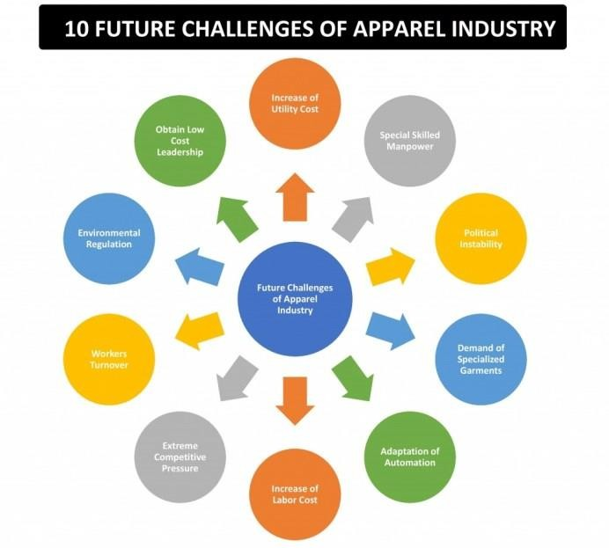

1. **The Increase of Utility Cost:**

Within the next several years, utility costs will probably rise significantly. Electricity, water, steam, and compressed air are the four utility kinds that are frequently utilised in a textile and apparel business. Electricity is the primary component of the utility among them since it may be utilised to obtain the other three. In a Bangladeshi or other country's garment factory, power is typically produced by one of two types of generators. The first is gas fuel, while the second is a diesel or oil-powered generator. Gas generator power is less expensive to produce. However, using a diesel generator would result in a two- to threefold rise in the cost of producing power. Our natural gas supply is quite constrained here in Bangladesh. We will eventually run out of natural gas, which means we will have to rely on diesel or some renewable energy source to generate industrial power.

Our entire cost of producing clothes will go up if we can't find a way to generate power at a reduced cost.

With the power distribution authority, the government may supply electricity to the industry as a solution to this issue. To start, the government must make sure there are high-capacity power plants all around the nation. Despite the enormous danger of an accident to the environment, the Bangladeshi government has already initiated action to build the nuclear power station.

1. **Special Skilled Manpower:**

Having some trained labour on hand is necessary to create some innovation. Specialized jobs may be completed proficiently and successfully via the use of unique abilities. special abilities such as operating a CNC machine, designing a PLC, using CAD, etc. Most garment workers in the industry are not highly educated, and it is difficult to find and manage specialised labour in particular. Owners in the garment business will thus face a significant problem.

More skill development initiatives should be adopted, such as the SEIP- Skilled Employment Investment Program implemented by the Bangladeshi government's Finance Ministry. The persons who participate in this programme will receive training, development, and job placement assistance. Other nations with developing garment industries might take inspiration from this progress and emulate it.

##### Political Instability:

The political unrest in Bangladesh is one of their biggest issues. For the sector to flourish positively, there must be a democratic government where there would be political stability. Shipment delays will be an issue in a nation where the transportation sector is frequently subject to strikes. Additionally, a shipment delay may result in the cancellation of the order, financial loss, or the loss of a crucial client. Therefore, enterprises that produce clothing need a favourable political environment. Bangladesh has a significant danger of political upheaval in the near future. The owner of the outfit is now considering how they would approach this situation.

To guarantee a stable political environment for their nation, the ruling administration might choose the simplest course of action.

##### Higher Demand for Specialized Garments Items:

The USA and Europe are the primary export markets for clothing. They were interested about fashion and will be more concerned about a distinctive trendy attire as their living standards are greater and are continuing to rise. Making affordable, attractive clothing in an industrial setting is therefore quite difficult. Owners of clothes must consider this issue and make investments in the creation of attractive clothing in order to meet the challenges that the apparel sector will face in the future.

Numerous inventive fashion designers and industrial engineers will be needed to create specialised clothing products in order to reduce the likelihood of a desire for diverse trendy apparel.

##### Adaptation of Automation:

Modern technology is assisting us in adjusting to automation in every industry. Numerous innovations have already been made, increasing production while requiring less manpower in the clothing industry. Modern technology is replacing men's strength, which indicates that the machine is taking the position of the person. Even while not every aspect of the textile and apparel business can be automated, some aspects of the garment industry can, which will improve the efficiency of both individual operations and the use of resources. If you do not have sufficient understanding of technology and the methods and sources you may use to adapt automation for your business, you will confront this difficulty as an industrialist. To deal with this challenge you must invest in developing skilled mechanical and industrial engineers who will be responsible for bringing automation to your factory. They will design and make a customized machine for the different sections of your factory.

##### An Increase of Labour Cost:

We have discovered that labour costs are rising everywhere every year. Compared to other nations, China and India are dealing with these issues far more than others. The garment business demands greater male strength since it is a more labour-intensive sector. Therefore, this difficulty cannot be avoided. This is the reason why Chinese businesses are moving around the globe and selecting Bangladesh and Africa as their ideal investment regions.

The clothing sector should focus on boosting worker productivity to lower the per- unit cost of labour in order to address the problem of rising labour costs. Another factor is that a good training and development plan has to be modified in order to guarantee uninterrupted output.

##### Extreme Competitive Pressure:

You are aware that competition is always present for you, regardless of where you conduct business. For business professionals, investing in the garment sector may be quite profitable because it generates significant profits for them. However, in order to make a significant profit in this cutthroat sector, you must first give a competitive pricing for their goods.

You just need to undertake a market analysis, a sourcing analysis for your materials, and an analysis of your export market before setting your targets. If you do a thorough study, you will undoubtedly discover a market for your product where you can make enough money to sustain your business.

##### 

##### Worker Turnover:

Employee or worker turnover is one of the major issues, and it presents a difficult challenge for textile and clothing business owners since, while they are untrained, they will appreciate your employment, but once they are skilled, they will want to migrate from one firm to another. The issue is that although you teach unskilled workers to become competent, you do not always guarantee that they will offer your business with their useful product once they are skilled. It resembles pressing lemon juice, but you are unable to consume it on your own. You are letting your competition grab your top employees while also losing your skilled personnel and investment money. This issue, in my opinion, represents the largest challenge facing the garment sector.

However, the question is: How can we solve this issue? The simplest option is to provide your employees a competitive benefit. First, ascertain their requirements and meet them, whether it be with a monetary or non-monetary advantage.

##### Extra Pressure from Environmental Regulatory Authority:

In the textile business, especially when chemicals are employed for dyeing, printing, and washing, a significant quantity of waste is produced that is ultimately thrown into river water. There is no effective way to reuse the enormous amounts of water needed for washing clothes. Our water is being contaminated by industrial waste and getting lower in elevation as a result of the garment industry. Because of this, environmental regulatory agencies are increasingly more worried about contamination in the environment. The environmental impact of disposing of used clothing is becoming a concern for garment consumers. ETPs, or effluent treatment plants, are now required in textile and apparel factories so that wastewater may be cleaned before being dumped into rivers. Here, the difficulty is in establishing an effluent treatment plant and operating it in accordance with the regulations of the relevant authorities, which is an expensive process.

As a business owner of clothing, you must pick the least expensive of three types of wastewater treatment facilities as a solution to this problem.

##### Obtain Low-Cost Leadership:

Today, finding low-cost leadership is difficult since everyone involved in the garment sector is looking for the best way to achieve it. They decide whether to make a choice themselves or purchase one as part of low-cost leadership.

Additionally, they are always attempting to establish effective supply chain management for the commodities used in their clothing.

How, therefore, can an industrialist guarantee low-cost leadership? Simply hire a qualified financial analyst. Let him fully comprehend your company's operations. After doing a thorough study, he will assist you in selecting the best course of action for you. Another thing you can do is to make sure you are knowledgeable about the business and how trends are developing. If you are knowledgeable enough and make the appropriate choice, you should be able to gain leadership in the apparel sector at a minimal cost.

After reading this, perhaps you have a better understanding of the potential issues facing the garment sector in the future and how to proceed in order to keep your company's business on the right track and earn a sufficient amount of money.

##### Outlook 2023 – Apparel industry challenges and opportunities



The fashion and clothing sector is volatile, and it has experienced several changes since the epidemic. Inflationary pressures have been driven by material shortages, transit bottlenecks, and increased shipping prices. According to McKinsey research, fashion executives may raise fashion garment prices by 3% in 2023 because of rising pressures.

On the bright side, the main potential for 2023 are examples of technologies, sustainability, and consumer engagement. Furthermore, the major issues in 2023 are expected to be distribution network, logistics, and inventory management, as well as sustainability.

##### Opportunities for growth in

##### 2023 Digital Technologies:

The introduction of new technology such as virtual personal assistants and digital fitting rooms has assisted firms in improving their customers' in-store experience. Furthermore, the introduction of Blockchain Technology, Artificial Intelligence, Metaverse, and other technologies would assist firms in releasing high quality items to the market faster and driving more income. According to estimates, 32% of fashion executives believe that digital technology would provide significant prospects in 2023.

**Consumer Engagement:** For fashion firms to compete on the market, consumer experiences across online and offline channels are important. Brands and retailers should increase their usage of data and analytics in order to build appropriate strategies. 11% of fashion executives believe that the year 2023 will assist companies and stores in recouping their losses caused by the epidemic

##### Fast fashion market: Global industry analysis and forecast

##### (2022-2029)

**In 2021, the Fast Fashion Market was estimated to be worth US$ 92.11 billion. One of the sectors examined in our analysis dominated the Fast Fashion Market offline.Fast Fashion Market Overview:**

To keep up with new trends, fast fashion clothes flows swiftly from the catwalk to the store. The fast-fashion market comprises the selling of fashionable clothing as well as related services. The latest fashion trends unveiled at Fashion Week help to boost the fast-fashion clothes line. Fast fashion provides the most recent catwalk trends at affordable rates and with little upkeep.

The year 2021 is used as a reference year to anticipate the market from 2022 through 2029. The market size in 2021 is based on genuine figures and outputs from key companies and big players throughout the world. When projecting the market until 2029, the previous five years' patterns are taken into account. 2021 is a year of exceptions, with a focus on the impact of lockdown by area.

##### Fast Fashion Market Dynamics:

Virtual reality and augmented reality are being used by both online and offline stores in the fast fashion business. In the fast fashion sector, the usage of virtual reality or augmented reality is intended to bridge the gap between online and physical channels. Customers may utilize these technologies to try on things and see how they appear when they try on clothes and makeup using their smartphone's virtual reality mirrors and cameras. The Dressing Room app, for example, employs augmented reality technology to allow customers to try on avatar outfits. The in-store experience is improved through virtual and augmented reality, which pushes the fast fashion sector. Unique, stylish, and economical clothing appeals to the youth demographic. As a result, garment producers are focused on delivering trendy clothes based on the most recent fashion trends shown at fashion week.

##### Fast Fashion Market Segment Analysis:

**By Gender,** In 2021, the Women's Segment held a 60% share of the market. Wearing the current fashion trend may have a significant impact on a woman's self-esteem, and having a closet full of a range of designs and colors is every woman's greatest goal. Women are more conscious of fashionable apparel and trends. These are the variables influencing market segment growth. During the projection period, the males category is estimated to rise at a CAGR of 5%. Rising awareness and rising trends in males are likely to boost category growth over the forecast period.

By Distribution ChannelIn 2021, the offline channel held a 59% share of the market. The most popular consumer tradition has been evaluating the product, touching the object, attractiveness, and size. Parking space and suitable operating hours, as well as the development in urbanization, are fueling demand for the offline channel. AR and VR are being introduced in a novel way in the offline market. Allowing customers to test on avatar costumes. These reasons are propelling the segment's market expansion. **During the** projection period, the online segment is predicted to develop at a CAGR of 7.1%. The development of E-Commerce owing to the availability of a diverse selection of items, product discounts, the ease of purchase, access to multiple sizes, colors, simple comparison, and so on.

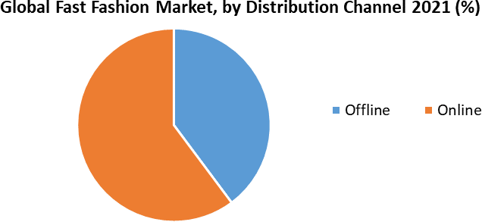

##### Fast Fashion Market Regional Insights:

In 2021, North America held a 38% share of the market. The rising popularity of quick fashion and thrift shopping among young people are fuelling the region's desire for rapid fashion. It is one of the most important marketplaces for quick fashion. Some multinational corporations that have offshored their manufacturing to reduce costs are also running short-run and replenishment facilities in the region to respond to the retail industry's quick-changing trends and to make rapid clothes.

Leading firms are implementing new technology and automating their supply chains. These are the reasons influencing regional market expansion.

During the projected period, the Asia Pacific Region is estimated to increase at a CAGR of 4%.In countries like as China, Japanese, and India, the rising standard of life, rise in disposable income, Social Networking Influencers, making people aware for quick clothes, and expanding population are driving the growth of the Asia Pacific Fast Fashion market. The report's goal is to provide industry stakeholders with a complete study of the Fast Fashion market. The research analyzes difficult data in simple language and presents the historical and current state of the industry, as well as anticipated market size and trends. The research examines all areas of the industry, including a detailed examination of important companies such as market leaders, competitors, and newcomers. The research includes a PORTER and PESTEL analysis, as well as the possible influence of market microeconomic aspects. External and internal elements that are expected to have a favorable or negative impact on the firm have been examined, providing decision-makers with a clear future vision of the industry. The study also aids in understanding the dynamics and structure of the Fast Fashion market by analyzing market segments and estimating the Fast Fashion market size. The study is an investor's guide because to its clear depiction of competitive analysis of key companies in the Fast Fashion market by product, price, financial situation, product portfolio, growth plans, and geographical presence.

##### Fast Fashion Market Key Players:

* ZARA
* H&M Group
* Fast Retailing
* Gap
* Forever 21
* Mango
* Esprit
* Primark
* New Look
* River Island
* Future Lifestyle Fashions Ltd

##### Impact of covid- 19 on fashion industry:

More than six months have passed since the International Health Organization designated the new coronavirus, COVID-19, a worldwide pandemic. COVID19 has already infected 215 nations and over 24 million people since its initial outbreak in Wuhan Province, China. Because COVID-19 is an airborne illness, substantial efforts are being made by numerous nations and governments to reduce human contact. COVID-19 is largely spread by respiratory droplets from sick patients to those in close contact, according to the WHO.

Contact with sick people or contaminated goods and surfaces. People have had to keep social distance, wear masks while leaving the house, and wash their hands as often as possible with soap and water. This has had serious implications, disturbing the lives of millions of individuals all over the world, as well as businesses, sectors, and the economy. That since start of the year 2020, the coronavirus pandemic has had an influence on people, economies, enterprises, and countries to a degree that no one could have dreamed or predicted. For the first time in years, more than 70 nations have been placed under harsher lockdown to prevent the spread of COVID-19, which has caused economic upheaval in a number of countries.

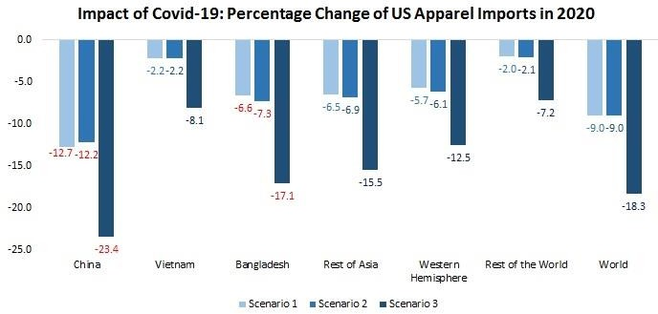

##### Fashion Industry in India- Laws and Legislations:

**The Indian Fashion Industry**

The fashion industry in India is strictly controlled. The country's fashion sector is governed by a variety of laws and regulations, most notably the Trade Marks Act, the Copyright Act, and the Designs Act.

You no longer have to worry about coming up with a firm name. The Vakilsearch company name generator may be used to generate a list of available firms.

Furthermore, the fashion business is subject to a variety of particular rules, such as those governing labeling and advertising.

##### Legal Actions:

The Competition Act of 1956 forbids any individual from abusing market power and provides for penalties for violators. The Trade Marks Act of 1970 governs trademark registration and protects trademarks from illegal use.

The Designs Act of 1926 protects the design of items and allows for design registration. The Copyright Act of 1957 guards against unlawful copying of literary and creative works.

The Trademark (Amendment) Act 2009 broadens the rights granted under the preceding Acts to include suggestive or geographically based trademarks, as well as the use of such trademarks in conjunction with services.

##### Government Initiative to Improve the Textile Sector in India:

India has a rich cultural past and a lengthy textile culture. India has grown into a major player in the global textile industry over the years. However, the industry is confronted with a number of obstacles, including high labor costs, low productivity, and a lack of infrastructure. In response to these issues, the Indian government has initiated a number of programs aimed at improving the textile industry. These measures include the establishment of new textile colleges and institutions, the development of new technologies, and an increase in industry investment.

Despite these attempts, India's textile sector remains undeveloped. This is due mostly to high labor costs and a scarcity of skilled people. As a result, many businesses rely on low-cost commodities such as Chinese cotton. To overcome these difficulties, the Indian government has initiated a number of programs that aim to enhance the quality of Indian textiles and increasing their worldwide competitiveness. These objectives include expanding textile entrepreneurs' access to finance and training, developing new marketing channels, and strengthening research and development in the sector. Furthermore, the government is aiming to improve textile sector infrastructure, such as greater manufacturing facilities and improved distribution channels.

CHAPTER - 3

RESEARCH DESIGN AND METHEDOLOGY

The research design for understanding trends in fast fashion and its influence on the apparel industry will be a combination of qualitative and quantitative methods. The research will be conducted using both primary and secondary data sources.

##### Methodology:

The methodology for the study on "The Analysis of Understanding the Trends in Fast Fashion and its Influence on Apparel Industry" will involve a comprehensive examination of the current literature on fast fashion and its impact on the apparel industry. This will include a review of academic journals, industry reports, and other relevant sources to identify key trends, drivers, and challenges related to fast fashion. The literature review will also provide background information and context for the study, and will inform the research questions and objectives.

To gather data for the study, a mixed-methods research design will be employed, incorporating both quantitative and qualitative methods. Quantitative data will be collected through surveys, which will be distributed to a sample of consumers to gather information on their attitudes and behaviours towards fast fashion. The survey will include questions on topics such as purchasing habits, brand loyalty, and awareness of sustainability issues in the fashion industry. Qualitative data will be collected through interviews with industry experts, such as fashion designers, apparel manufacturers, and retail executives, as well as case studies of specific fast fashion companies and their business practices. This will provide in-depth insights into the challenges and opportunities presented by fast fashion, as well as the impact of fast fashion on the apparel industry.

.

RESEARCH QUESTIONS:

* 1. NAME
  2. GENDER
     + MALE
     + FEMALE
     + PREFER NOT TO SAY
  3. EMAIL
  4. EDUCATIONAL QUALIFICATION
     + POSTGRADUATE
     + UNDERGRADUATE
     + DIPLOMA
     + OTHERS
  5. How fashion is important

|  |  |  |  |  |  |  |
| --- | --- | --- | --- | --- | --- | --- |
| 1 | 2 | 3 | 4 | 5 | 6 | 7 |

* 1. How fashionable I am

|  |  |  |  |  |  |  |
| --- | --- | --- | --- | --- | --- | --- |
| 1 | 2 | 3 | 4 | 5 | 6 | 7 |

* 1. The factors that influence me to make decision for "SHOPPING"
     + TREND
     + OFFER
     + SEASON
     + OTHERS
  2. Do you shop with Fast Fashion Brands
     + YES
     + NO
     + MAYBE
  3. The Fast Fashion Brand prefer to buy
     + H&M
     + ZARA
     + FOREVER 21
     + OTHERS
  4. I often buy fast fashion Brands

|  |  |  |  |  |  |  |
| --- | --- | --- | --- | --- | --- | --- |
| 1 | 2 | 3 | 4 | 5 | 6 | 7 |

* 1. How long I wear the fast fashion Cloths

|  |  |  |  |  |  |  |
| --- | --- | --- | --- | --- | --- | --- |
| 1 | 2 | 3 | 4 | 5 | 6 | 7 |

* 1. I prefer the products which are recycled

|  |  |  |  |  |  |  |
| --- | --- | --- | --- | --- | --- | --- |
| 1 | 2 | 3 | 4 | 5 | 6 | 7 |

* 1. I encourage store recycling

|  |  |  |  |  |  |  |
| --- | --- | --- | --- | --- | --- | --- |
| 1 | 2 | 3 | 4 | 5 | 6 | 7 |

* 1. It is sustainable to buy second hand Fast Fashion products

|  |  |  |  |  |  |  |
| --- | --- | --- | --- | --- | --- | --- |
| 1 | 2 | 3 | 4 | 5 | 6 | 7 |

* 1. Sustainable Fashion is always Expensive

|  |  |  |  |  |  |  |
| --- | --- | --- | --- | --- | --- | --- |
| 1 | 2 | 3 | 4 | 5 | 6 | 7 |

* 1. I think celebrities are influencing the youth toward Fast Fashion

|  |  |  |  |  |  |  |
| --- | --- | --- | --- | --- | --- | --- |
| 1 | 2 | 3 | 4 | 5 | 6 | 7 |

* 1. Fast Fashion is forcing retailers to keep low prices according to the Design and Quality

|  |  |  |  |  |  |  |
| --- | --- | --- | --- | --- | --- | --- |
| 1 | 2 | 3 | 4 | 5 | 6 | 7 |

* 1. Marketing and Advertising are necessary for Fast Fashion

|  |  |  |  |  |  |  |
| --- | --- | --- | --- | --- | --- | --- |
| 1 | 2 | 3 | 4 | 5 | 6 | 7 |

* 1. I consider the negative impacts of Fast Fashion

|  |  |  |  |  |  |  |
| --- | --- | --- | --- | --- | --- | --- |
| 1 | 2 | 3 | 4 | 5 | 6 | 7 |

**Statement of the Problem:**

Fast fashion, defined as the rapid turnover of designs in the fashion industry, has become a prevalent and controversial issue in recent years. While fast fashion allows for increased accessibility and affordability of trendy clothing, it also raises concerns about environmental sustainability and ethical labor practices. The purpose of this research is to understand the trends and drivers behind fast fashion, as well as its impact on the apparel industry as a whole. Specifically, the research will aim to answer questions such as: How have consumer attitudes and behaviors towards fast fashion changed over time? What are the key drivers behind the fast fashion business model? How is the fast fashion trend affecting the environment and labor conditions in the apparel industry? By understanding these trends and their impact, this research aims to provide insights that can inform industry practices and policy decisions towards a more sustainable and ethical fashion industry.

### Need for the study:

Firstly, fast fashion has become a significant aspect of the fashion industry, with many companies relying on the fast turnover of designs to stay competitive and meet consumer demand. However, this business model has also been criticized for its negative impact on the environment and labor conditions. Therefore, there is a need to understand the trends and drivers behind fast fashion in order to inform industry practices and policy decisions towards more sustainable and ethical fashion.

Secondly, consumer attitudes and behaviors towards fast fashion are constantly evolving. Therefore, studying the trends in fast fashion will help to understand how consumer attitudes and behaviors have changed over time and how they are expected to change in the future. This understanding can assist the fashion industry in adapting to the changing demands of consumers.

Thirdly, studying the impact of fast fashion on the apparel industry as a whole will help to identify the challenges and opportunities that this trend presents for the industry. This understanding can assist the fashion industry in making strategic decisions to address these challenges and capitalize on these opportunities.

Overall, the need for this study is to understand the trends, drivers, and impact of fast fashion on the apparel industry, so as to develop sustainable and ethical practices in the fashion industry.

### Objectives of the study

* To identify and analyze the trends and drivers behind fast fashion in the apparel industry.
* To understand how consumer attitudes and behaviors towards fast fashion have changed over time and how they are expected to change in the future.
* To assess the impact of fast fashion on the environment and labor conditions in the apparel industry.
* To provide insights into the challenges and opportunities that fast fashion presents for the apparel industry.
* To develop recommendations for sustainable and ethical practices in the fashion industry based on the findings of the study.

### Literature Review:

The fashion apparel sector has grown tremendously, notably in the previous 20 years, when the industry's borders began to expand. The fashion industry's shifting dynamics since then, such as the waning .The advent of mass manufacturing, a rise in the number of fashion seasons, and altered structural elements in the supply chain have compelled retailers to seek low cost and flexibility in design, quality, delivery, and time to market. Marketing and capital investment, in addition to speed to market and design, have been recognized as driving drivers of competitiveness in the fashion garment business, with'sense and respond' as the important approach to retain a profitable position in the more dynamic and demanding market. A significant distinguishing feature of higher responsiveness and flexibility(Bhardwaj & Fairhurst, 2010)

Today's fashion market is very competitive, and the ongoing need to refresh product ranges imply that many stores will unavoidably increase the number of seasons,' or the frequency with which the whole stock within a store is replaced. Fashion merchants are encouraging consumers to visit their stores more frequently with the concept of 'Here Today, Gone Tomorrow' with the appearance of limited selections of items. This implies a shorter life cycle and larger profit margins from the sale of fast-moving products, as opposed to avoiding the markdown process entirely. Furthermore, the need for variety and fast satisfaction with price mavens motivates customers to select businesses like as Zara and H&M**.** (Bhardwaj & Fairhurst, 2010)

Zara is a specialized fashion chain and a good example of a fast fashion store, with quick product turnover and vertical integration. Zara is often regarded as a fast fashion pioneer. However, Zara's popularity is due to its concentration on a restricted variety of and basic forms, resulting in a very limited product selection. However, fast fashion does not apply to the whole store range, and as much as 80% of items may be core and basic lines, with quick fashion accounting for up to 20%. The instances examined in this research provide rapid fashion as well as other items. (Bruce & Daly, 2006)

Purchasing activities play a critical part in fast fashion through supplier selection and product decision-making, and buying is arguably shifting from merely operational to considerably more strategic. Through case studies involving a supermarket, department shop, and own brand label, this study tackles the complexities of fast fashion purchasing. It is stated that efficient fast fashion buying behavior relies on the management of a supplier portfolio, relationship development, and effectively interacting with internal operations.(Bruce & Daly, 2006)

Because of the worldwide nature of the garment industry's supply networks, good communication is critical. Using technology to help with communication with manufacturers can contribute to a faster response by delaying judgments about color, fabric, and form. The later these judgments are made, the more likely they are to represent current consumer preferences properly. The speed with which merchants and manufactures communicate is not the sole determinant in rapid response.

argue that the risks associated with offshore sourcing may be substantially avoided if buyers and suppliers create a high level of trust, or if the buyer has a presence in the place of manufacturing to guarantee standards are maintained. Vertical integration can make this link formal.(Hayes & Jones, 2006)

H&M's current ratio has fluctuated tremendously but has always been more than one.French Connection's ratio, as well as New Look's and Principles', have improved in recent years to attain healthy ratios of more than one. Bon Marche' has stayed somewhat consistent, and while their ratio has fallen below one, it is not in an unsafe situation because it has remained relatively constant. Next and Zara have extremely low ratios, as does Primark, whose ratio has substantially decreased. (Hayes & Jones, 2006)

The phrase “fast fashion” refers to low-cost clothing collections that mimic current luxury fashion trends. Fast fashion helps sate deeply held desires among young consumers in the industrialized world for luxury fashion, even as it embodies unsustainability. Trends run their course with lightning speed, with

today’s latest styles swiftly trumping yesterday’s, which have already been consigned to the trash bin. This article addresses the inherent dissonance among fast fashion consumers,who often share a concern for environmental issues even as they indulge in consumer patterns antithetical to ecological best practices.(Joy et al., 2012)

The fashion industry has long been a labor-intensive sector in which companies' competitor success is generally driven by cost-cutting strategies based on locating supplies of low-wage labor and work intensifying to achieve production targets . Actual assembling jobs are primarily piece rate, with semi-skilled operators doing routinized, regulated, and frequently low-value-added activities. The supervisory function of management impacted work speed indirectly through wage rate manipulations and more sophisticated methods of coercing what was frequently a big pool of pliant younger female workers.(Taplin, 2014

With the fast advancement of science and technology, as well as ever-increasing customer expectations, the percentage of products showing perishability is increasing, affecting a wide range of businesses.

Because of its unique characteristics, such as short life cycle goods, variable demand, limited predictability, a high degree of impulsive buy, a high level of price competitiveness, and worldwide sourcing, this study focuses on the fast fashion garment business. A system dynamics model with three supply chain levels is suggested for analyzing the behavior and linkages of the fast fashion garment sector. The Conditional Value at Risk (CVAR) metric is used to evaluate the risks associated with these items' supply chains as well as to calculate the expected value of losses.(Mehrjoo & Pasek, 2016)

Because of the rising importance of external finance required for expanding commercial transactions, one of the key developments in the twentieth century was the distinct separation of the function of firm owners from the function of enterprise managers. In actuality, corporate managers wield undue authority and influence over what happens both inside and outside the organization. On the push side, for stable and sustainable growth, society expects management behaviors to adhere to ethical norms and be oriented toward the common benefit and interest of society.(Nguyen et al., 2020)

"Fast fashion" - the phrase used to describe, among other aspects, Retailers' tactics for fast and effectively reflecting current and upcoming trends in current goods assortments - poses key challenges regarding the procedures of successful merchandise management. Category management (CM) tactics have been implemented in the retail grocery industry to re-align commercial buyer and manufacturer (as supplier) connections to make them more cooperative and therefore more responsive to market opportunities. Defined as "the strategic administration of product groupings through trade alliances with the goal of increasing sales and profitability by meeting consumer wants."(Sheridan et al., 2006)

The global garment chain has been described as an archetypal example of a buyer- driven global supply chain, with revenues coming from "multiple alleles of high- value study, design, selling, marketing, and finance services that enable retailers, branded marketers, and labeled manufacturers to operate as strategic brokers in connecting foreign factories"2 with customers. These characteristics were supposed to separate commodity chains in garments and other employment industries such as apparel and entertainment from production company chains (e.g., in automobiles) that were managed and controlled by upstream producers rather than bottom middlemen.(*ZARA: Fast Fashion*, 2003)

Environmental sustainability is becoming increasingly essential in the garment sector. Primary practices include replacing toxic chemicals with ecologically friendly materials and reusing clothing to reduce waste and resource usage. A more Slow fashion is a recent sustainable industry initiative. It is a socially aware movement that encourages individuals to buy high-quality products less frequently, shifting their thoughts from quantity to value (Fletcher). Slow fashion includes both slow creation and slow consumption. Slow production does not use natural or human resources to accelerate manufacturing speed (Fletcher), and slow consumption results in a longer product lifecycle from manufacturing to disposal.

Although the idea of slow fashion is not restricted to environmental sustainability, any unique features that make between slow fashion and ecologically sustainable fashion remains ambiguous.(Jung & Jin, 2014)

This might be due to a lack of scholarly knowledge of slow fashion, despite the increasing interest in slow fashion in reality. The goal of this research is to investigate the aspects of slow fashion using Churchill's measurement development model. This study seeks to characterize slow fashion conceptually with underlying characteristics using the scale item development evaluating consumer orientations to slow fashion. A review of literature and a clear poll were used to produce the first scale items. The questions were then purified and verified using two surveys (with student and non-student groups) in the Southeastern United States.(Jung & Jin, 2014)

The purpose of this research is to provide a thorough evaluation of the state-of- the-art of artificial intelligence (AI) applications in the garment sector. The available literature is examined in light of several research concerns and AI-based approaches. On the basis of the operating procedures of the garment sector, the study concerns are divided into four categories: apparel design, production, retailing, and logistics management. By assessing the limits of past studies and research problems, this study demonstrates that research on Ai technologies in the garment sector is still restricted.(Guo et al., 2011)

Artificial intelligence has had a huge influence on the fashion and garment industries over the last few decades. However, research in this area is dispersed and primarily focused on one level of the supply chain. As a result, understanding the work done in the specific realm of the Fashion and Apparel Industry is challenging. As a result, the purpose of this research is to investigate the influence and relevance of Artificial Intelligence in the Clothing and Apparel Industry during the previous several decades across the supply chain. Following this goal, we conducted a systematic evaluation of research publications (Journal and Conference) on ai technology in the fashion and clothing business. The articles were obtained from two well-known databases, "Scopus" and "Web of Science."(Giri et al., 2019)

Sustainable supply chain strategies have been developed over the last several decades to incorporate ecological problems into business by reducing accidental detrimental impacts on the environment throughout the production and purchasing processes. At the same time, circular economies push the limits of environmental sustainability by emphasizing the concept of inventive goods, therefore establishing a feasible link between ecosystems and economic expansion. This research analyzes four themesddrivers, challenges, practices, and indicators of sustainability development when using a circular economy in the textile and apparel sector by a thorough literature analysis. Based on these four themes, we develop a conceptual model that depicts their interrelation. We identify problems in implementing the circular economy and make some recommendations to textile and apparel sector executives.(Jia et al., 2020)

In the garment manufacturing industry, the conventional mass production method is contrasted with new strategies focused on cooperation and increased employee engagement. Despite the fact that economic factors have supported So far, these tactics have only been deployed inside traditional strategies for human resources that preserve significant divisions between production employees on the one hand and executives, supervisors, and scientists on the other.(Bailey, n.d.)

Garment makers must deal with a vast range of clothing kinds, which may be essentially split into two categories: outside clothing and inside clothing.

Workwear and uniforms, leisure wear, and sportswear are examples of outer clothing Jersey goods and lingerie These goods are made in a variety of design and style variants, which adds to the production process's intricacy.

## **CHAPTER - 4**

## **DATA ANALYSIS AND INTERPRETATION**

#### Table 1.1: Gender

|  |  |
| --- | --- |
| particulars | Frequency |
| Male | 63 |
| Female | 60 |

Figure 1.1: Gender

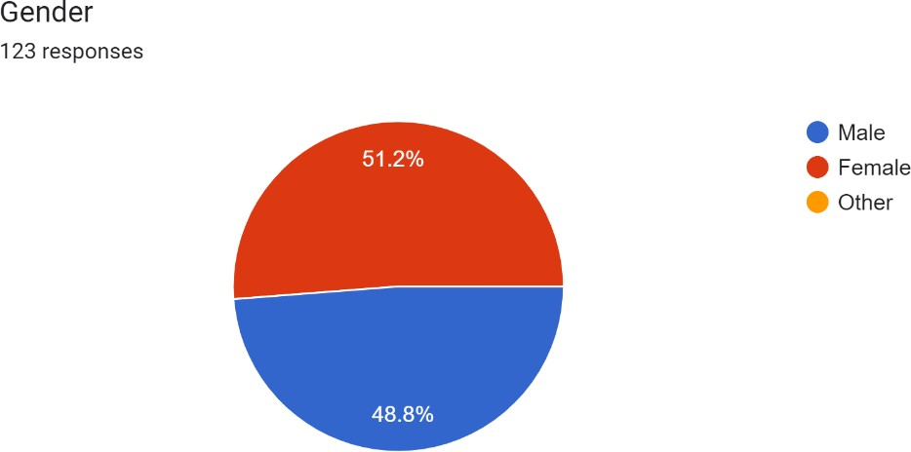

Interpretation:

Table 1.1 shows the frequency of males and females in a certain group or population. There are 63 males and 60 females. This table gives a general idea of the gender distribution within the group or population, but it does not provide any information on the relationship between gender and other variables

#### Table 1.2: educational background

|  |  |
| --- | --- |
| Particulars | Frequency |
| Postgraduate | 45 |
| Undergraduate | 67 |
| Diploma | 3 |
| Others | 8 |

Figure 1.2:

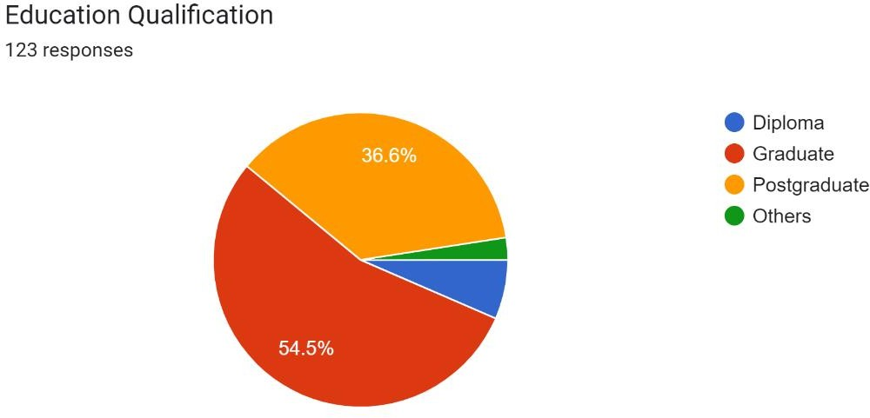

Interpretation:

Table 1.2 shows the frequency of individuals in a sample grouped by their educational background. There are 45 individuals in the sample who have a postgraduate degree, 67 individuals with an undergraduate degree, 3 individuals with a diploma, and 8 individuals who fall under the "Others" category. This table provides a general overview of the educational background of the sample population.

#### Table 1.3: annual income

|  |  |
| --- | --- |
| Particulars | Frequency |
| Less than 2,50,000 | 63 |
| 2,50,000 - 5,00,000 | 50 |
| 5,00,000 - 10,00,000 | 9 |
| More than 10,00,000 | 1 |

Figure 1.3 : annual income

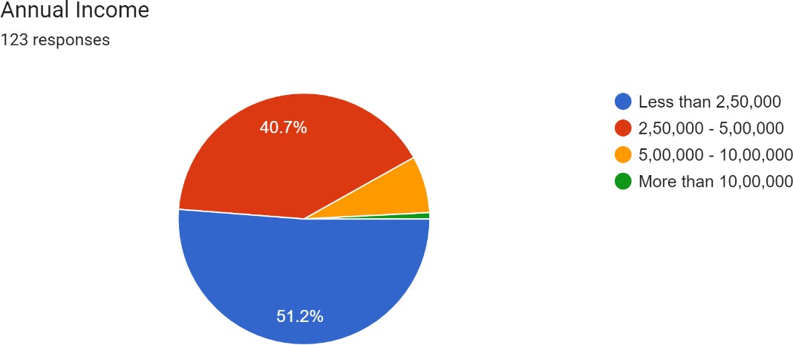

Interpretation:

Table 1.3 shows the frequency of individuals in different annual income groups. There are 63 individuals with an annual income less than 2,50,000, 50 individuals with an annual income between 2,50,000 and 5,00,000, 9 individuals with an annual income between 5,00,000 and 10,00,000, and 1 individual with an annual income more than 10,00,000. This information can be used to understand the income distribution of the individuals in the sample and how it might be related to other factors or characteristics of the individuals

#### Table 1.4 : HOW FASHION IS IMPORTANT

|  |  |
| --- | --- |
| Particulars | Frequency |
| High | 95 |
| Neutral | 14 |
| Low | 14 |

Figure 1.4 : HOW FASHION IS IMPORTANT

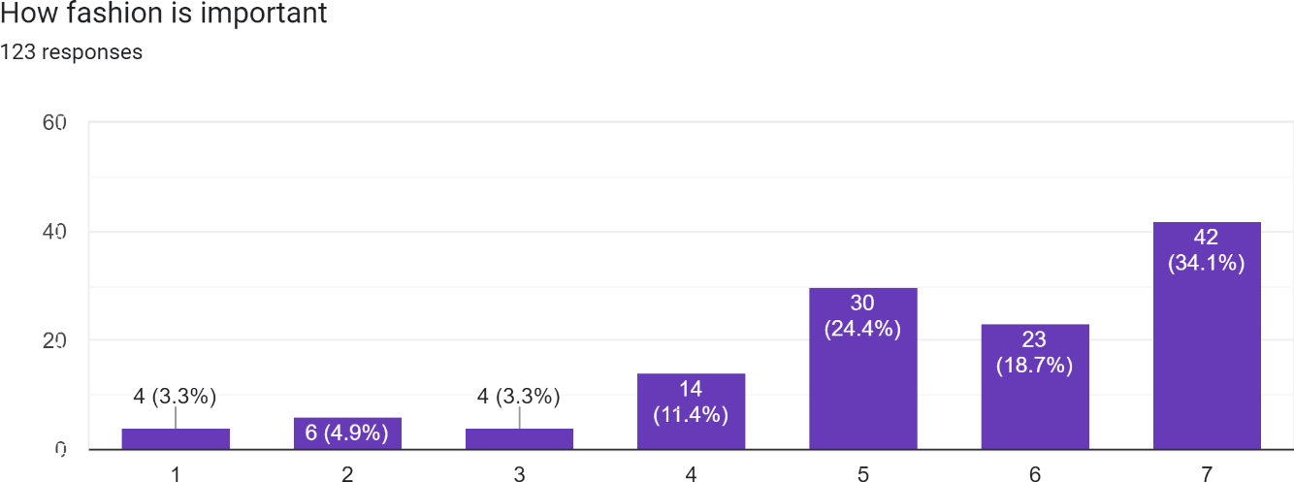

Interpretation:

Table 1.4 shows the results of a survey on how important fashion is to a group of people. The table shows the frequency of each response, which is the number of people who gave that particular answer. The results show that the majority of people (95) consider fashion to be very important to them. A smaller number of people (14) said that fashion is somewhat important to them or not important at all. This suggests that the majority of the surveyed group places a high value on fashion.

#### Table 1.5: HOW FASHIONABLE I AM

|  |  |
| --- | --- |
| Particulars | Frequency |
| High | 82 |
| Neutral | 26 |
| Low | 15 |

Figure 1.5: HOW FASHIONABLE I AM

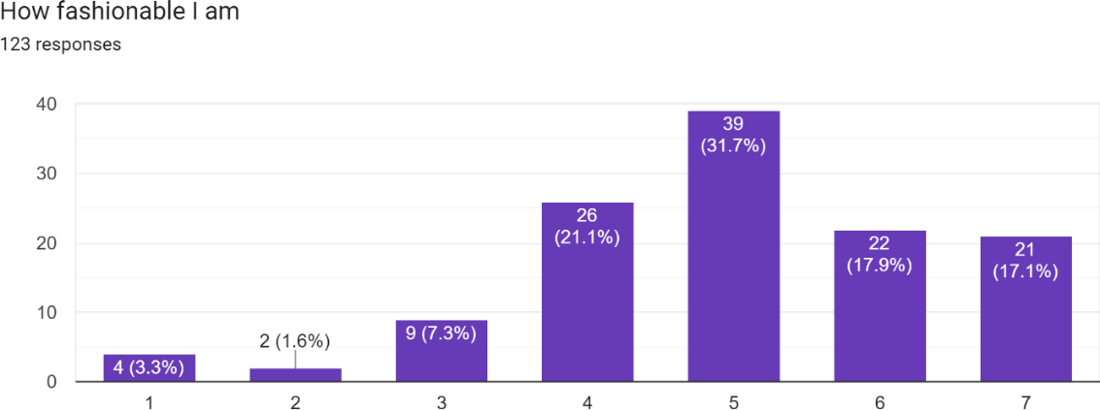

Interpretation:

Table 1.5 presents the results of a survey on how fashionable the respondents consider themselves to be. It shows that a majority of the respondents, 82 out of 123, consider themselves to be highly fashionable. There were 26 respondents who considered themselves to be neutral in terms of fashionability and 15 respondents considered themselves to be low in fashionability. This suggests that a majority of the respondents have a high level of confidence in their fashion sense.

#### Table 1.6 : DO YOU SHOP WITH FAST FASHION BRANDS

|  |  |
| --- | --- |
| Particulars | Frequency |
| Yes | 49 |
| No | 20 |
| Maybe | 54 |

Figure 1.6: DO YOU SHOP WITH FAST FASHION BRANDS

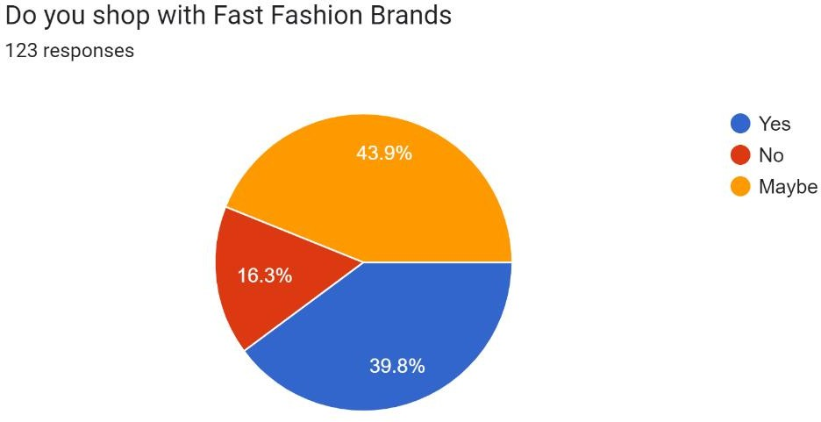

Interpretation:

Table 1.6 shows the responses of participants on whether they shop with fast fashion brands. The table indicates that 49 participants answered "Yes", 20 answered "No", and 54 answered "Maybe." This suggests that a majority of the participants are uncertain about their shopping habits with fast fashion brands, with some participants indicating that they do shop with fast fashion brands and others indicating that they do not.

#### **T-test :**

t-Test: Two-Sample Assuming Equal Variances

|  |  |  |
| --- | --- | --- |
|  | *Female* | *Male* |
| Mean | 76.66667 | 69.88889 |
| Variance | 5645.227 | 4203.828 |
| Observations | 45 | 45 |
| Pooled Variance | 4924.528 |  |
| Hypothesized Mean Difference | 0 |  |
| df | 88 |  |
| t Stat | 0.458138 |  |
| P(T<=t) one-tail | 0.323991 |  |
| t Critical one-tail | 1.662354 |  |
| P(T<=t) two-tail | 0.647983 |  |
| t Critical two-tail | 1.98729 |  |

Interpretation:

the t-statistic is 0.458138, and the p-value is 0.323991. This means that there is a 0.323991 probability that the difference between the means of the two groups (Female and Male) is due to chance. Since the p-value is not less than 0.05, it can be concluded that there is not a significant difference between the means of the two groups (Female and Male).

With the given data, it can be inferred that there is no significant difference in the means of the two groups (Female and Male) in terms of their variable being tested.

#### Anova :

Anova: Single Factor

|  |  |  |  |  |
| --- | --- | --- | --- | --- |
| SUMMARY |  |  |  |  |
| *Groups* | *Count* | *Sum* | *Average* | *Variance* |
| Diploma | 43 | 453 | 10.53488 | 1432.683 |
| Graduate | 43 | 3574 | 83.11628 | 5647.534 |
| Others | 43 | 155 | 3.604651 | 184.1495 |
| Postgraduate | 43 | 2413 | 56.11628 | 3105.915 |

|  |  |  |  |  |  |  |
| --- | --- | --- | --- | --- | --- | --- |
| ANOVA |  |  |  |  |  |  |
| *Source of Variation* | *SS* | *df* | *MS* | *F* | *P-value* | *F crit* |
| Between Groups | 184924.9 | 3 | 61641.65 | 23.77627 | 7.08E-  13 | 2.658399 |
| Within Groups | 435551.8 | 168 | 2592.57 |  |  |  |
|  |  |  |  |  |  |  |
| Total | 620476.8 | 171 |  |  |  |  |

Interpretation:

The ANOVA table is showing the results of a statistical test used to determine if there is a significant difference in the mean of a dependent variable (in this case, the frequency of the educational background) between two or more groups (in this case, diploma, graduate, others, and postgraduate). The table shows that the source of variation is between groups and the sum of squares (SS), degrees of freedom (df), mean squares (MS), F-value, and p-value. The p-value is less than 0.05, which indicates that there is a significant difference in the mean of the educational background between the groups and the null hypothesis (that there is no significant difference in the mean of the educational background between the groups) is rejected. The F-critical value for this test is 2.658399, and the calculated F-value is 23.77627 which is greater than F-critical value, so the null hypothesis is rejected and we can say that there is a significant difference in the educational background of the participants.

#### Anova :

Anova: Single Factor

|  |  |  |  |  |
| --- | --- | --- | --- | --- |
| SUMMARY |  |  |  |  |
| *Groups* | *Count* | *Sum* | *Average* | *Variance* |
| 2,50,000 -  5,00,000 | 43 | 2656 | 61.7674  4 | 3483.37  3 |
| 5,00,000 -  10,00,000 | 43 | 529 | 12.3023  3 | 596.882  6 |
| Less than 2,50,000 | 43 | 3351 | 77.9302  3 | 5966.30  5 |
| More than 10,00,000 | 43 | 59 | 1.37209  3 | 80.9534  9 |

|  |  |  |  |  |  |  |
| --- | --- | --- | --- | --- | --- | --- |
| ANOVA |  |  |  |  |  |  |
| *Source of Variation* | *SS* | *df* | *MS* | *F* | *P-value* | *F crit* |
| Between Groups | 178915.  2 | 3 | 59638.3  9 | 23.555 | 8.91E-  13 | 2.65839  9 |
| Within Groups | 425355.  6 | 168 | 2531.87  8 |  |  |  |
|  |  |  |  |  |  |  |
| Total | 604270.  8 | 171 |  |  |  |  |

Interpretation:

The ANOVA table is a statistical test that compares the means of multiple groups to determine whether there is a significant difference between them. In this case, the table is showing the results of an ANOVA test comparing the annual income groups: "2,50,000 - 5,00,000", "5,00,000 - 10,00,000", "Less than 2,50,000", and

"More than 10,00,000".

In this table the P-value is less than 0.05, which means that the annual income groups are significantly different from each other. The F statistic is 23.555 which is greater than the critical value of 2.658399. This suggests that there is a significant difference between the annual income groups.

#### **Regression :**

Summary output:

|  |  |
| --- | --- |
| *Regressi on Statistics* |  |
| Multiple R | 0.64096  8 |
| R Square | 0.41084 |
| Adjusted R Square | 0.40593 |
| Standard Error | 7.14028  3 |
| Observat ions | 122 |

|  |  |  |  |  |  |
| --- | --- | --- | --- | --- | --- |
| ANOVA |  |  |  |  |  |
|  | *df* | *SS* | *MS* | *F* | *Significa nce F* |
| Regressi on | 1 | 4266.  3 | 4266.  3 | 83.67  978 | 1.84E-  15 |
| Residual | 120 | 6118.  037 | 50.98  364 |  |  |
| Total | 121 | 10384  .34 |  |  |  |

|  |  |  |  |  |  |  |  |  |
| --- | --- | --- | --- | --- | --- | --- | --- | --- |
|  | *Coeffici ents* | *Stand ard Error* | *t Stat* | *P-*  *value* | *Lower 95%* | *Upper 95%* | *Lower 95.0%* | *Upper 95.0%* |
|  | 18.7693 | 2.191 | 8.563 | 4.34E- | 14.4299 | 23.10 | 14.42 | 23.10 |
| Intercept | 6 | 688 | 882 | 14 | 7 | 875 | 997 | 875 |
|  | 3.89523 | 0.425 | 9.147 | 1.84E- | 3.05214 | 4.738 | 3.052 | 4.738 |
| 6 | 1 | 817 | 665 | 15 | 3 | 319 | 143 | 319 |

Interpretation:

The regression analysis is used to understand how the independent variable(s) are related to the dependent variable. In this case, the summary output shows that the independent variable (X) is 6, and the dependent variable (Y) is not specified. The R-squared value is 0.41084, which means that 41% of the variation in the dependent variable can be explained by the independent variable. The p-value for the independent variable (X) is less than 0.05, which indicates that it is statistically significant. The coefficient for the independent variable (X) is 3.895231, which means that for every one unit increase in the independent variable, the dependent variable is expected to increase by 3.895231 units. The 95% confidence interval for the independent variable (X) is between 3.052143 and 4.738319. Overall, the results suggest that there is a positive relationship between the independent variable and the dependent variable, and the independent variable is statistically significant in explaining the variation in the dependent variable.

#### **Regression :**

Summary output

|  |  |
| --- | --- |
| *Regressi on Statistics* |  |
| Multiple | 0.57137 |
| R | 3 |
| R Square | 0.32646  7 |
| Adjusted | 0.32085 |
| R Square | 4 |
| Standard Error | 7.63446 |
| Observat ions | 122 |

|  |  |  |  |  |  |
| --- | --- | --- | --- | --- | --- |
| ANOVA |  |  |  |  |  |
|  | *df* | *SS* | *MS* | *F* | *Significa nce F* |
| Regressi on | 1 | 3390.  138 | 3390.  138 | 58.16  487 | 6.3E-12 |
| Residual | 120 | 6994.  198 | 58.28  498 |  |  |
| Total | 121 | 10384  .34 |  |  |  |

|  |  |  |  |  |  |  |  |  |
| --- | --- | --- | --- | --- | --- | --- | --- | --- |
|  | *Coeffici ents* | *Stand ard*  *Error* | *t Stat* | *P-*  *value* | *Lower 95%* | *Upper 95%* | *Lower 95.0%* | *Upper 95.0%* |
|  |  | 2.394 | 8.540 | 4.93E- | 15.7057 | 25.18 | 15.70 | 25.18 |
| Intercept | 20.4457 | 001 | 389 | 14 | 4 | 566 | 574 | 566 |
|  | 3.22636 | 0.423 | 7.626 | 6.3E- | 2.38876 | 4.063 | 2.388 | 4.063 |
| 5 | 1 | 041 | 59 | 12 | 9 | 953 | 769 | 953 |

Interpretation:

The ANOVA table shows the results of the hypothesis test that the population coefficients are equal to zero. The F-statistic is 58.16487 and the corresponding p- value is 6.3E-12, which is less than 0.05, so we can reject the null hypothesis and conclude that at least one of the population coefficients is not equal to zero.

The coefficients table shows the estimates of the population coefficients and their standard errors. The coefficients are the values of b0 and b1 in the regression equation. In this case, the estimate of the population intercept is 20.4457 and the estimate of the population coefficient of x is 3.226361. The t-statistic and coefficient is equal to zero. Since p-value is less than 0.05, we can reject the null hypothesis and conclude that the population coefficient is not equal to zero.

The lower and upper 95% are the 95% confidence interval for the population coefficients.

So, the interpretation of this output is that there is a moderate positive linear relationship between the independent variable x and the dependent variable y. And, the independent variable x is a significant predictor of the dependent variable y. The population intercept is 20.4457 and the population coefficient of x is 3.226361.

#### Regression :

Summary output

|  |  |
| --- | --- |
| *Regressi on Statistics* |  |
| Multiple | 0.60783 |
| R | 3 |
| R Square | 0.36946  1 |
| Adjusted | 0.36420 |
| R Square | 6 |
| Standard | 7.38677 |
| Error | 5 |
| Observat ions | 122 |

|  |  |  |  |  |  |
| --- | --- | --- | --- | --- | --- |
| ANOVA |  |  |  |  |  |
|  | *df* | *SS* | *MS* | *F* | *Significa nce F* |
| Regressi on | 1 | 3836.  603 | 3836.  603 | 70.31  325 | 1.13E-  13 |
| Residual | 120 | 6547.  733 | 54.56  444 |  |  |
| Total | 121 | 10384  .34 |  |  |  |

|  |  |  |  |  |  |  |  |  |
| --- | --- | --- | --- | --- | --- | --- | --- | --- |
|  | *Coeffici ents* | *Stand*  *ard Error* | *t Stat* | *P-*  *value* | *Lower 95%* | *Upper 95%* | *Lower 95.0%* | *Upper 95.0%* |
|  |  | 2.339 | 8.172 | 3.53E- | 14.4910 | 23.75 | 14.49 | 23.75 |
| Intercept | 19.1239 | 902 | 949 | 13 | 6 | 675 | 106 | 675 |
|  | 3.53994 | 0.422 | 8.385 | 1.13E- | 2.70409 | 4.375 | 2.704 | 4.375 |
| 5 | 4 | 161 | 3 | 13 | 5 | 793 | 095 | 793 |

Interpretation:

The "Multiple R" value is a measure of the correlation between the predicted and actual values of the dependent variable. In this case, it is 0.607833, which indicates a moderate positive correlation.

The "R Square" value is a measure of the proportion of the variance in the dependent variable that is predictable from the independent variable(s). In this case, it is 0.369461, which indicates that about 37% of the variance in the dependent variable can be explained by the independent variable.

The "Adjusted R Square" value is similar to R Square but adjusted for the number of independent variables in the model. In this case, it is 0.364206.

The "Standard Error" value is a measure of the average distance that the residuals (prediction errors) fall from the regression line. In this case, it is 7.386775.

#### Correlation:

|  |  |  |
| --- | --- | --- |
|  | *How fashion is important* | *How fashionable I am* |
| How fashion is important | 1 |  |
| How fashionable I am | 0.673454 | 1 |

Interpretation:

The correlation table you provided shows the relationship between two variables: "How fashion is important" and "How fashionable I am." The correlation coefficient for the two variables is 0.673454, which indicates a strong positive correlation. This means that as one variable increases, the other variable also tends to increase. In this case, as the respondent's perception of the importance of fashion increases, so does their perception of their own fashionability

#### Correlation:

|  |  |  |
| --- | --- | --- |
|  | *I often buy fast fashion*  *Brands* | *How long I wear the fast fashion*  *Cloths* |
| I often buy fast fashion  Brands | 1 |  |
| How long do I wear the fast  fashion Cloths | 0.752906 | 1 |

Interpretation:

The correlation coefficient between "I often buy fast fashion Brands" and "How long I wear the fast fashion Cloths" is 0.752906. This suggests a strong positive correlation between the two variables, meaning that as one variable increases (i.e. the frequency of buying fast fashion brands) the other variable also tends to increase (i.e. the length of time wearing fast fashion clothes). However, it is important to note that correlation does not imply causation.

##### CHAPTER - 5

##### SUGGESTIONS, FINDINGS , CONCLUSION.

**Summary of findings:**

Fast fashion is a trend in the apparel industry characterized by the rapid production and sale of large quantities of clothing at low prices, often at the expense of quality and sustainability. Fast fashion companies often produce multiple collections per year, with new styles and designs introduced on a regular basis. The trend is driven by a desire to keep up with the latest fashion trends and consumer demand for new clothing.

The fast fashion industry has been criticized for its negative impact on the environment, worker rights, and consumer behaviour. The production and disposal of cheap clothing contributes to pollution and waste. Additionally, the fast fashion industry often employs low-cost labour, which can result in poor working conditions and low wages for workers.

The rise of fast fashion has also led to a culture of disposability, where people view clothing as disposable rather than something to be treasured and cared for. This has led to a increase in the frequency and volume of clothes being bought and discarded.

However, there is a growing awareness and demand for sustainable and ethical fashion, which may lead to a shift in the apparel industry towards more responsible production and consumption practices. Consumers are becoming more conscious of the environmental and social impacts of their clothing choices and are looking for sustainable options.

Overall, fast fashion has had a significant impact on the apparel industry, with trends towards faster production, lower costs, and disposable clothing driving changes in the industry. However, it also has negative impacts on worker rights, the environment, and consumer behaviour. The industry is facing a challenge to adapt to the changing consumer demands and regulations.

##### Conclusion:

In conclusion, fast fashion is a trend in the apparel industry that has had a significant impact on the way clothing is produced, consumed, and disposed of. The practice of rapidly producing and selling large quantities of clothing at low prices has led to negative consequences for the environment, worker rights, and consumer behaviour.

However, it's important to note that the apparel industry is complex and there are multiple players involved. The fast fashion trend is not limited to a few companies but an industry wide phenomenon. Consumers are becoming more conscious of the environmental and social impacts of their clothing choices and are looking for sustainable options. This has led to a growing awareness and demand for sustainable and ethical fashion.

The industry is facing a challenge to adapt to the changing consumer demands and regulations. The industry is moving towards more responsible production and consumption practices. It's important for the industry to balance the need for fast and affordable fashion with the need for sustainability and ethical practices. The future of the apparel industry will depend on how well it is able to address these challenges and adapt to changing consumer preferences.

##### Recommendations:

1. Increase transparency in the supply chain: Companies should provide clear and detailed information about where and how their products are made, including information on materials, labour practices, and environmental impacts.
2. Invest in sustainable production practices: Companies should invest in sustainable production practices, such as using eco-friendly materials and reducing waste and pollution.
3. Promote circular economy: Companies should focus on designing and producing garments that have a longer life cycle, and encourage customers to recycle, repair or resell them.
4. Support fair labour practices: Companies should ensure that workers in their supply chain are treated fairly and paid a living wage. This can be achieved through audits, certifications and better working conditions.
5. Educate customers: Companies should educate customers about the impacts of fast fashion and the importance of sustainable and ethical consumption.
6. Collaboration and Partnership: Companies should collaborate with other industry players, such as textile mills, suppliers, retailers and governments, to create sustainable supply chain practices.
7. Government policies: Government should implement policies and regulations that encourage sustainable and ethical practices in the apparel industry, such as minimum wage laws, labour standards, and environmental regulations.
8. Consumer awareness: Consumers should be more aware of the environmental and social impact of their clothing choices and demand sustainable and ethical options from apparel companies.
9. Encourage the use of digital technologies: Companies should adopt the use of digital technologies such as 3D printing and virtual try-ons, to reduce waste and improve efficiency.
10. Invest in R&D: Companies should invest in research and development to find new sustainable materials, processes, and technologies that can reduce the environmental impact of the apparel industry.

Bibliography:

Bailey, T. (n.d.). *Organizational Innovation in the Apparel Industry*.

Bhardwaj, V., & Fairhurst, A. (2010). Fast fashion: Response to changes in the fashion industry. *International Review of Retail, Distribution and Consumer Research*, *20*(1), 165–173. https://doi.org/10.1080/09593960903498300

Bruce, M., & Daly, L. (2006). Buyer behaviour for fast fashion. *Journal of Fashion Marketing and Management*, *10*(3), 329–344. https://doi.org/10.1108/13612020610679303

Giri, C., Jain, S., Zeng, X., & Bruniaux, P. (2019). A Detailed Review of Artificial Intelligence Applied in the Fashion and Apparel Industry. *IEEE Access*, *7*, 95376– 95396. https://doi.org/10.1109/ACCESS.2019.2928979

Guo, Z. X., Wong, W. K., Leung, S. Y. S., & Li, M. (2011). Applications of artificial intelligence in the apparel industry: A review. In *Textile Research Journal* (Vol. 81, Issue 18, pp. 1871–1892). SAGE Publications Ltd. https://doi.org/10.1177/0040517511411968

Hayes, S. G., & Jones, N. (2006). Fast fashion: A financial snapshot. *Journal of Fashion Marketing and Management*, *10*(3), 282–300. https://doi.org/10.1108/13612020610679277

Jia, F., Yin, S., Chen, L., & Chen, X. (2020). The circular economy in the textile and apparel industry: A systematic literature review. In *Journal of Cleaner Production* (Vol. 259). Elsevier Ltd. https://doi.org/10.1016/j.jclepro.2020.120728

Joy, A., Sherry, J. F., Venkatesh, A., Wang, J., & Chan, R. (2012). Fast fashion, sustainability, and the ethical appeal of luxury brands. *Fashion Theory - Journal of Dress Body and Culture*, *16*(3), 273–295. https://doi.org/10.2752/175174112X13340749707123

Jung, S., & Jin, B. (2014). A theoretical investigation of slow fashion: Sustainable future of the apparel industry. *International Journal of Consumer Studies*, *38*(5), 510–519. https://doi.org/10.1111/ijcs.12127

Mehrjoo, M., & Pasek, Z. J. (2016). Risk assessment for the supply chain of fast fashion apparel industry: A system dynamics framework. *International Journal of Production Research*, *54*(1), 28–48. https://doi.org/10.1080/00207543.2014.997405

Nguyen, H. T., Le, D. M. D., Ho, T. T. M., & Nguyen, P. M. (2020). Enhancing sustainability in the contemporary model of CSR: a case of fast fashion industry in developing

countries. In *Social Responsibility Journal* (Vol. 17, Issue 4, pp. 578–591). Emerald Group Holdings Ltd. https://doi.org/10.1108/SRJ-03-2019-0108

Sheridan, M., Moore, C., & Nobbs, K. (2006). Fast fashion requires fast marketing: The role of category management in fast fashion positioning. In *Journal of Fashion Marketing and Management* (Vol. 10, Issue 3, pp. 301–315). https://doi.org/10.1108/13612020610679286

Taplin, I. M. (2014). Global commodity chains and fast fashion: How the apparel industry continues to re-invent itself. *Competition and Change*, *18*(3), 246–264. https://doi.org/10.1179/1024529414Z.00000000059

*ZARA: Fast Fashion*. (2003). [http://www.hbsp.harvard.edu.](http://www.hbsp.harvard.edu/)